Project Hestia

NASA AMES SPACE SETTLEMENT

2016-2017

Hestia





The Hestia Project is a submission to the

2016-17 NASA AMES SPACE SETTLEMENT.

This project was submitted by the students of NARAYANA E-TECHNO SCHOOL.

Submitted by the 9th and 10th standard small group category.

Contents

0.0. Naming 6

0.1. Acknowledgements and authors 7

0.2. Abbreviation and Terminology 8

1. HESTIA
2. Overview 9
3. Structure 10
4. Construction 12
5. Shield 14

2.0 PAN 17

1. Agricultural Area 18

3.0 OLA 25

3.1 Residential Area 29

3.2 Cafeteria 30

3.3 Hospital 31

3.4 Entertainment 35

3.5 Control Panel 40

3.6 Harvest Center 45

3.7 Kitchen 47

3.8 Laboratories 51

4.0 POSEIDON 53

4.1 Water Management 54

5.0 Life support 55

1. Human Factor 55
2. Sanitation 57
3. Atmosphere 67
4. Interior 69
5. Orbit 70
6. Artificial Gravity 73
7. Clothing 75

6.0 Technology 79

1. Power supply 79
2. Communication Systems 82
3. Nano bots 84
4. Docking station 86
5. Rockets 87

7.0 Human Resource 93

1. Law Enforcement 93
2. Night and Day 95

8.0 Lunar Base 97

9.0 Conclusion 100

10.0 Bibliography 101

Naming

Project HESTIA was derived from the Greek virgin goddess who resembled hearth or home. We intend to shine light into the unknown universe and explore beyond our imagination. Hearth means the fireplace in the house or a place where warmth and light is there, making us comfortable in the cold winter providing us with the required warmth. With this project, we intend to provide warmth for the future residents in the space station “Hestia” and hope for a better future of mankind.

HESTIA is a project that aims for the advancement in human civilization and hopes that we continue our race for future generations to come. Space is a place where the conditions are very harsh and conditions cannot be taken lightly as they can result in severe damage.

Thus, to avoid complications we have taken outmost care in designing the project and making it comfortable for humans to live in.

The name literally means comfort and warmth to the people in or surrounding the place so to live up to the name we must make the space station strong and durable without making people uncomfortable.

Acknowledgments

We have many people to thank for. They literally made this happen. We mainly thank our parents who helped us at times when we were faced difficulties and even empowered us. We also thank our principals and the principal of our school, we would also like to thank our physics teacher. The main people who helped us the most is the school management who provided us with the required materials and helped us in this this project. This is our second-time participating in the NASA AMES-NSS settlement project. We were mainly inspired from our previous project, which was flawed but drove us this year to learn from our mistakes and improvise.

Our principal Mr. Mahendra Varman who drove us with enthusiasm, he helped us a lot and motivated us to succeed in this project. He guided us throughout this project and he helped us find if any flaws existed.

Authors

Vachan SJ (Narayana E-Techno (Blr-Kag), grade 10)

Saketh Aripirala (Narayana E-Techno (Blr-Kag), grade 10)

Hemanth Bysani (Narayana E-Techno (Blr-Kag), grade 9)

Sirish Sekar (Narayana E-Techno (Blr-Kag), grade 9)

Affan Ahmed (Narayana E-Techno (Blr-Kag), grade 9)

Abbreviation and Terminology

PAN: Agricultural area.

Poseidon: Water storage.

OLA: The citizens of Hestia live only in OLA and all amenities are present here.

HSS: Hestia Space Shuttle. The rocket which will be used for Hestia.

SOS: Superior operating system. The operating system for Hestia’s Computers.

UI TV: User Interface T.V.

NRO: Near rectilinear orbit. The orbit in which orbit is going to operate.

Group: Each group will consist of 4 Sectors.

Sectors: Each sector will consist of 960 people.

UST: Urine separation toilets

UDDT: Urine diversion dry toilets

EVA suit: Extra vehicular activity suit

ACASS: Automatic condensed aerosol suppression system

**Hestia**

Overview

The main aim of project HESTIA is to help humanity advance in science and provide a suitable place in our solar system for humans. These two factors are responsible for creation of this project, there are many places in our solar system which are suitable for human settlement, but none of them provide a comfortable experience for humans. This has forced us to make a settlement near the earth so that we will not fall short of supplies and can maintain communication with the people on earth. There are many factors which decide the place in which we are going to place our space station. Hestia will be for 11,520 people and can accommodate 500 people at any given time.

There are millions of conditions and factors which may hamper with our space station thus, we have researched and found out the best place for our space settlement. The place which we have decided upon is near the moon and the orbit in which we are going to orbit is called NRO orbit. This orbit has been proven to sustain and maintain the object in its orbit. We have taken care of almost everything that is needed by the humans to remain comfortable and keep their health in perfect condition. We have truly made our space station self-dependent and safe for humans to stay in.

With this project, we aim to explore the mysteries of the Universe and unlock the full potential of humans.

**1.1 STRUCTURE**

Hestia’s structural design is rather simple and is made of the regularly used components such as tori and cylinders. Hestia will be rotating on its own axis to produce pseudo gravity. Hestia consists of a residential torus, water tori, agricultural zone, spokes, docking port and a microgravity center.

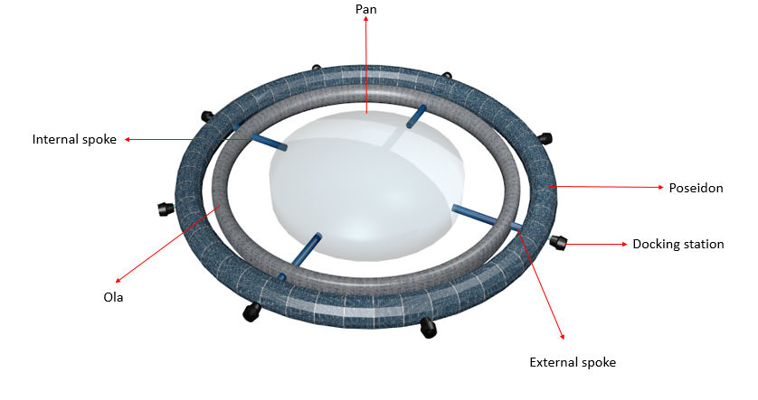

Fig 1: structure of HESTIA

In the middle of the entire structure a cylinder will be built which is the agricultural zone. This cylinder is 285 meters in radius and 80 meters in height. The agricultural zone is a massive structure and is required since food is a very essential component for the residents on the space settlement. The massive structure of the agricultural zone makes it self-sufficient and food scarcity will never occur on Hestia. In the same way, excessive supplies of food will not be produced and if produced it will be stored and not thrown away. Hestia can accommodate more number of residents then it has been built for and has abundant amount of space for residents to freely roam, the residents will never feel that they have been restricted to a confined space. Four small cylinders have been attached to the agricultural zone which will act as spokes for connecting the rest of the structure to the agricultural zone. These four spokes have a radius of 10.5 meters and a height of 122 meters. The residential tori are attached to these four spokes and it has almost everything the people require. The residential torus has a minor and major radius of 31.4 meters and 438.4 meters respectively. To the residential tori another four spokes have been attached, these spokes will connect the outer tori to the residential tori. These spokes have a radius of 10.5 meters and height 50.6 meters. The outer tori are the water tori and has a minor and major radius of 40 meters and 529 meters respectively. The final component of the settlement is the docking station and there will be eight such docking stations. Each docking station has two components. The first component of the docking station consists of one spoke of radius 5 meters and height 6 meters respectively. The second component of the docking station is one docking port; the docking port structure and mechanism have been explained in the further sections of the project.

**1.2 CONSTRUCTION**

The construction of Hestia will take place in the NRO orbit, initially a cylinder of radius 285 meter and height 80 meter will be built in the NRO orbit. This cylinder will not directly be launched into orbit as it is physically impossible to launch such a massive structure into space. Hence, small parts of the cylinder will be sent into the orbit to form the initial framework of the cylinder. The outer part of the cylinder consisting of the rectangular sheets (as shown in the figure) will be constructed and attached to one another to form the initial framework of the cylinder. 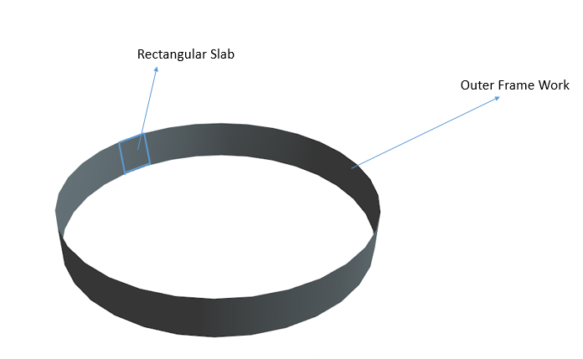

Fig 2: Outer framework of PAN

Then the base of the cylinder will be constructed to the framework. The name given to this huge cylinder is PAN, named after the Greek god of harvest. After this has been done, the upper portion of pan will be built to complete the construction of pan. Four smaller cylinders will be built which have a height of 122 meter and radius 10.5 meter. These smaller cylinders will later be attached to pan; the purpose of these cylinders is that they will act as spokes as mentioned in the previous section. The next component of the settlement is a hybrid torus which will be attached to the four small cylinders. This torus has been named after the Greek word óla which means all, we have named it óla because this torus will contain almost all the necessary components to sustain life. After óla’s construction has been completed, four other cylinders will be attached to óla. These cylinders will serve as a connection from óla to another torus. This other torus will contain water; portions of this torus will be filled with water and used for various purposes. This torus has been named as Poseidon. After the construction of Poseidon has been completed, four docking stations will be attached to Poseidon. The docking station has two components namely one cylinder, and one docking port. The design of the docking port and its mechanism have been explained in the rocket section of the project. There will be 8 docking stations. Initially one cylinders will be built and attached to Poseidon, after the construction of this structure is completed, one docking port will be attached to complete the docking station. This completes the structure of the entire space station. When we combine all these parts together, we get Hestia. Hestia isn’t such a massive structure and the entire length of the project comes under 2 kilo meters.

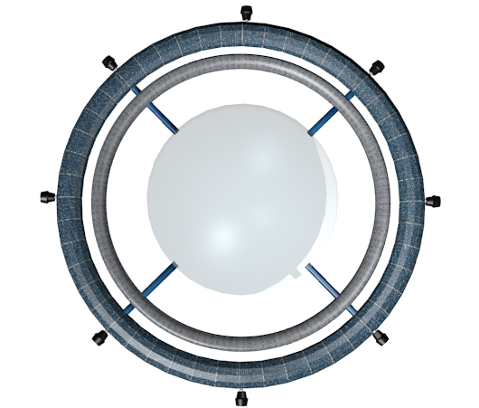

Fig 3: HESTIA

**1.3 DEBRIS SHIELD**

When orbiting the lunar orbit (NRO) there are many chances of debris impacting the structure. So, to avoid this we have built a debris shield within the entire structure. The main way of protection is by using our walls as shielding. The secondary way of protecting our structure is by using ion shielding. More of the ion shield will be briefly be explained below. These walls are mainly built to withstand huge impacts of asteroids and another factor is micro asteroids. These micro-asteroids are very small sized but tend to travel at great speeds and can almost make holes in the structure. The wall is built using various layers that are given in the figure below.

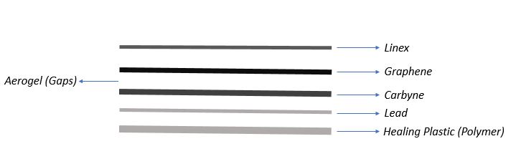

***Fig 4- Wall layers, each line representing the thickness of a layer.***

So, as we’ve seen the above image we can understand the layers of walls built into Hestia. Each of the layer will be briefly explained below:

*Line-x:*

It is a protective layer of paint that is made of Diphenylmethane-4,4’-diisocyanate and polyol/resin. This layer of paint can withstand a large amount of stress on it. During construction on each of the panel before placement are coated with this material. It is said to have a tensile strength of about 6,600psi.

Hence it can take on micro-meteorites with ease. If in case any decompression occurs, it can hold all the materials inside instead of blasting them into space. This layer of coating is only 0.02cm thick

*Graphene:*

It is a commonly used material. It is not only a strong material and thin but also an electricity conducting material. We intend to use this material for its flexibility, strength and conductivity. It can transmit electricity faster than copper and aluminum. So instead of running cables for electricity, we can just build it around the circumference of the structure. It is also a flexible material so it can prove to be handy in building the structure. This layer is only 1cm thick.

*Aerogel:*

Aerogel is a solid form of gas. It is a very good insulator of heat and electricity. Silica aerogel is known to be the best heat insulator and one of the lightest materials produced with good rigidity. Since, it is placed in between gaps it allows us to avoid interference with the graphene placed for electricity. It also helps us in avoiding heat from space entering our settlement. In a way, even this keeps our inhabitants warm and comfortable. This layer is only 0.25cm thick in each gap.

*Carbine:*

It is the strongest yet the lightest material. It has been proven to be stronger than graphene. It helps us in providing extreme rigidity and makes our settlement “micro-asteroid proof”. By placing it in the exact center of the entire wall it helps us in protecting the internal structure. This layer is only 1.2 cm thick.

*Lead:*

Lead is a dense material but the main purpose of its usage in our structure is to provide radiation protection. There are many radiation forms in our solar system such as Cosmic rays, solar flares, solar winds, alpha, beta and gamma radiations. These are very harmful to us humans as many major forms of cancers are caused by radiations. But to make this dense material from weighing our structure down, we have used a very small amount of it. It is approximately only about 0.5 cm thick.

*Healing plastic:*

It is our last line of defense. It is a type of polymer that can take an impact and restore back to its original shape. But the only issue is that it is a time taking to repair itself from big impacts. But the main intention of placing this is to provide protection from small bullet sized impacts. This layer is only 1cm thick.

Thus, the entire walls thickness is only about 4.72cm thick.

***1.3.1 ION Shield:***

Ion shield is like the magnetosphere of earth. By placing this and making a large field of ion shielding it can help us in burning off any debris. The ion shielding is not only said to provide complete protection from any debris it can also stop particles released by the sun. These solar particles can prove harmful as they can interfere with the flow of data transmission and communication. These solar particles are Positively charged particles. Thus, this an important form of protection from debris. As it acts as a magnetosphere it needs a large amount of electricity. The ion shield is provided electricity from the internal power supply itself. We have a huge amount of excess so we intend to use it for the ion shielding. So, as described in the power supply section of this booklet we have mw of excess so we are using this to power the ion shielding. The ion shield tends to heat up very much so the all layers are very effective in this case.

**2.0 PAN**

The cylinder located at the center has been named as pan, this is the agriculture cylinder as mentioned in the previous section. The agriculture cylinder has been named as ‘Pan’ because ‘Pan’ is the Greek god of harvest. The agriculture zone has been divided into 3 layers, the first layer has been made into a microgravity center where people will experience zero gravity. The second and third layers’ have been made into the agriculture units where all the crops will be grown. Another important feature of pan is that it is made of a transparent glass that allows the sun’s rays to fall on the crops, this transparent glass has been induced with a thin layer of zinc to block harmful radiations from the sun. The entire description of the agriculture zone has been given in the upcoming sections of the project.

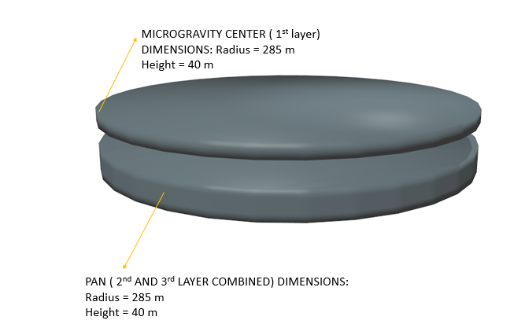

**Fig-5: Representation of PAN and Microgravity center independently**

The two layers are not actually separate from each other; we have shown them independently for distinguishing the microgravity center from PAN.

**2.1 AGRICULTURAL SECTOR**

The main component of any organism’s survival is energy which is got from food. Without food, none of the astronauts will be able to survive. So, it is highly essential for any space station to have an agricultural sector, especially which can be self-sufficient in the long run. Just staying self-sufficient might not be enough in case of an emergency, so we must make sure to grow enough crops for more than the designated number of people living in our station.

The main factors to consider while building our agricultural sector, is the name of the area, types of crops, method of cultivation and harvesting, components and nutrients required, yield per hectare, radius of our agricultural dome, number of calories and nutrients stored in them and finally, time taken to grow these crops.

To call it as an agricultural sector, feels a little bland. We hence call it PAN named after the Greek deity of harvest.

The human body requires different types of nutrients and minerals. To supplement all these needs, we made a list of important types of food we need. We will grow food rich in carbohydrates and fats to provide us with energy, vitamins, proteins, minerals and fiber to keep or bodies running smoothly. We then considered the factors of yield per hectare, calories per 100g and time taken to harvest it. Finally, we arrived at a perfectly logical conclusion of the following crops:

|  |  |  |  |  |  |
| --- | --- | --- | --- | --- | --- |
| **CARBOHYDRATES** | **FATS** | **PROTEIN** | **VITAMIN** | **MINERAL** | **FIBER** |
| **Potato** | Cottage cheese | Milk | Finger Millet | Bitter Gourd | Beans |
| **Wheat** | Cheese | Corn | Carrot | Tomatoes | Peas |
| **Brown Rice** | Groundnut | Beetroot | Sweet Potato | Cabbage | Barley |

Currently there are many ways of cultivating crops. We will be applying the strategy of aeroponics. Aeroponics has many advantages over traditional methods of cultivation. Mainly, it uses 98% lesser amount of water, does not need soil to grow which reduces the mass of the ship greatly, nearly halves the growing period, doubles the yield per hectare and multiple crops can be grown in the same area. These factors beat traditional methods of cultivation when in space, where many of the essentials are scarce.

The crops will be grown in a structure like that of a rack with three floors. The crops will be grown in both bases. The crop grown in the first base will not get sunlight but rather light from LED bulbs placed under the third base. Either way, plant is not harmed as the LED bulbs do the same job as the sun; that is breaking down water into hydrogen and oxygen which is highly essential for the plant. The first base will be raised to the height of length of root of each crop. There will be special sprays located underneath the roots. They will contain water, nutrients and important minerals and gases mixed very well. The quantum computer will direct the sprays to function as and when it is necessary for the plant, cutting down wastage of our essentials.

When the crop is ready to harvest, workers will remotely control robotic arms located near the crops to cut those yields and transport them to the storage room. No human will be allowed to go inside the agricultural room unless it is an emergency.

The optimal temperature at which a crop grows very well is a variable for all plants. The temperature will be monitored by sensors located at constant intervals on the racks. It will then be regulated by the sprays located in the bottom of the base.

The water requirement is very precise and carefully monitored by the sensors and will regulate the amount of water supplied. The p[H] value of the water will be stipulated to that of the crop requirement. Nutrients which are vital for the growth of the plants will be mixed accurately with the supplied water and sprayed on the roots of the plants. This way, all the important components required for plant growth is carefully supplied and wastage is reduced.

The requirements of each plant are unique. We have hence made a list of all the characters necessary in the development of a crop in the table given below:

|  |  |  |  |  |
| --- | --- | --- | --- | --- |
| **CROP/ REQUIREMENTS** | **TEMPERATURE** | **p[H] VALUE** | **WATER(litres)** | **NUTRIENTS** |
| **POTATO** | 18-20 | 5.2-6.4 | 10000 | S, Fe, Mg, MN |
| **SWEET POTATO** | 16-18 | 5.6-6.5 | 60000 | Ca, Mg, B |
| **GROUNDNUT** | 30-32 | 6.5-7.0 | 1302000 | Ca, S, Mg |
| **BROWN RICE** | 20-27 | 5.5-6.5 | 378000 | Fe, Si |
| **CARROT** | 15-18 | 6.5-7.5 | 11333 | Ca, Mg |
| **CABBAGE** | 18-20 | 6.0-6.8 | 5000 | Mg, Mo, Na, Fe |
| **TOMATO** | 21-23 | 6.0-7.0 | 30000 | Fe, MN |
| **BEETROOTS** | 18-24 | 6.5-7.0 | 231000 | B, Mo |
| **CORN** | 15-18 | 6.0-6.8 | 60000 | Ca, Mg, S |
| **BITTER GOURD** | 24-31 | 5.5-6.7 | 30000 | Si, Fe |
| **FINGER MILLET** | 24-27 | 7.0-8.0 | 280000 | Fe, Mg, Mn |
| **WHEAT** | 14-18 | 6.0-6.4 | 105000 | S, Zn, Cu, B, Mn |
| **BARLEY** | 13-17 | 6.5-7.0 | 44400 | Zn, Cu, S |
| **BEANS** | 15-21 | 6.0-6.5 | 33000 | Fe |
| **PEAS** | 15-20 | 6.0-7.5 | 350000 | Fe, Cu, Mg |
| **SOY** | 20-23 | 6.0-6.8 | 28000 | Mo, Fe, Cu |

The individual requirements will be monitored by the quantum computers and special gadgets installed in PAN.

Each crop yields different amount of yield. To calculate how much we need of each crop, we must resolve logically. We take an average of 12000 people each of whom need an average of 300 calories per day:

|  |  |  |  |
| --- | --- | --- | --- |
| **CROP** | **CALORIES PER 100g** | **CROP** | **CALORIES PER 100g** |
| **POTATO** | 80 | **BITTER GOURD** | 35 |
| **SWEET POTATO** | 90 | **FINGER MILLET** | 320 |
| **GROUNDNUT** | 560 | **WHEAT** | 330 |
| **BROWN RICE** | 11 | **BARLEY** | 350 |
| **CARROT** | 40 | **BEANS** | 40 |
| **CABBAGE** | 30 | **PEAS** | 80 |
| **TOMATO** | 20 | **MILK** | 130 |
| **BEETROOT** | 40 | **CHEESE** | 240 |
| **CORN** | 365 | **COTTAGE CHEESE** | 140 |

Since all humans are unique with their own special requirements, we prepare three sequences each of which will contain all the six essentials required by the human body. Three different types of sequences for each human reduces the probability of the human getting bored of it. Different sequences will be awarded to different people based on their behavior, efficiency and most of all, deficiency in nutrients. We also make different kinds of dish as the food cannot be eaten raw. We have made special taste enhancers to make the food tasty and attractive. The sequences are given below: (next page)

|  |  |  |  |
| --- | --- | --- | --- |
| **TYPE/SEQUENCE** | **SEQUENCE 1** | **SEQUENCE 2** | **SEQUENCE 3** |
| **CARBOHYDRATE** | Wheat | Potato | Brown Rice |
| **FATS** | Cheese | Groundnut | Cottage Cheese |
| **PROTEINS** | Corn | Beetroots | Milk |
| **VITAMINS** | Carrot | Finger Millet | Sweet potato |
| **MINERALS** | Tomato | Bitter Gourd | Cabbage |
| **FIBER** | Beans | Peas | Barley |
| **CALORIE INTAKE** | **3050** | **3300** | **2550** |

On an average, 4000 people are awarded the same sequence. Summing up all the calories received per 100g in each sequence, we find that 300g of crop must be supplied in each sequence. Although we do get varied results of more than, equal to and less than 3000 calories independently in each sequence, we award each of it to different people to supplement their deficiencies.

Each day, 1230kgs of food is required. As we have stated before, plants are unique and hence, each of them yield their harvest in their own time. Therefore, we multiply the number of days with 1230kgs for each crop and get a unique integer for every single crop.

Yield produced by each crop is different and hence we must proportionate the area stipulated for each crop by the unique integer established in the last paragraph.

We then receive another value, which is the area needed to grow a crop to supplement 4000 people till the time it gives its second harvest. The area must be divided in half as we grow two crops in the same area.

We than arrive at different values of area for each crop. We now notice that some crops need very less space to be grown in. OLA has a lot of space in its second floor. We can utilize this space to accommodate a few of the crops which need very less space to grow. Carrots, cabbages, tomatoes, potatoes, beetroots, bitter melons, beans peas and stevia can be grown sufficiently in this space, thereby reducing the total area PAN.

The remaining crops will be grown in PAN. The areas which we arrived at two paragraphs ago, must be added together. this then gives us the value of the area of a circle. Since we have two PANs, we again divide it by two. This value of area is the area of one circular dome. We divide this value by *pi* constant and find the root of that value. This is the radius of the PAN.

In this way, we conclude that the radius of an individual PAN is averaged out to 285m. this conclusion is totally scientific and logical as we have considered all the factors possible and have also reduced waste space as we have utilized everything to the fullest.

The details of all the crops has been given below in the table: (next page)

|  |  |  |  |  |
| --- | --- | --- | --- | --- |
| **CROP/ DETAILS** | **YIELP PER HECTARE (tonnes)** | **TIME TILL HARVEST (days)** | **DAILY REQUIREMENT (kg)** | **REQUIREMENT TILL HARVEST (tonnes)** |
| **POTATO** | 50 | 40 | 1230 | 50 |
| **SWEET POTATO** | 31 | 50 | 1230 | 50 |
| **GROUNDNUT** | 1 | 50 | 1230 | 62 |
| **BROWN RICE** | 8 | 56 | 1230 | 69 |
| **CARROT** | 75 | 40 | 1230 | 50 |
| **CABBAGE** | 115 | 40 | 1230 | 50 |
| **TOMATO** | 105 | 25 | 1230 | 31 |
| **BEETROOT** | 50 | 50 | 1230 | 62 |
| **CORN** | 15 | 35 | 1230 | 44 |
| **BITTER GOURD** | 65 | 50 | 1230 | 62 |
| **FINGER MILLET** | 5 | 56 | 1230 | 69 |
| **WHEAT** | 10 | 56 | 1230 | 69 |
| **BARLEY** | 10 | 30 | 1230 | 37 |
| **BEANS** | 35 | 30 | 1230 | 37 |
| **PEAS** | 10 | 20 | 1230 | 25 |
| **SOY** | 10 | 25 | 3690 | 27 |

There are two different PANs. One of them is filled with groundnuts, whereas another dome is made of varied crops. They have their own designated angle as they are in the form of a sector. Their areas and angles of sector are given in the table below: (next page)

|  |  |  |
| --- | --- | --- |
| **CROP** | **TOTAL AREA (m^2)** | **ANGLE OF SECTOR** |
| **SWEET POTATO** | 10000 | 14.1079 |
| **GROUNDNUT** | 310000 | 76.1842 |
| **BROWN RICE** | 40000 | 56.4231 |
| **CORN** | 15000 | 21.0065 |
| **FINGER MILLET** | 65000 | 91.7014 |
| **WHEAT** | 35000 | 49.3777 |
| **BARLEY** | 18500 | 25.0996 |
| **SOY** | 18500 | 26.0996 |
|  | **551750** | **360** |

We also grow another special plant commonly called stevia. Stevia is an herbaceous plant whose leaves are very sweet. It is 200% sweeter than commercially available sugar and does not have any of the harmful calories in it. It does not contain any calories but is very sweet. In some our dishes, we use stevia as a substitute for sugar.

Once the plant completes its life cycle, it will all be transported to the biogas chamber. In this bio gas chamber, we stash all the plants, which anaerobically decompose to give out gases like methane (CH4), carbon di-oxide (CO2) etcetera. These gases can be used to produce electricity and run many appliances.

Once the biomass has fully decomposed, it will again be transported to a special chamber where all the nutrients are sucked out from it. The plants are basically squashed to give out very useful liquid which contains many nutrients and minerals. This liquid will then be sent to the sprays whose plants need it. This hence reduces the nutrient and water wastage, as everything has been reused and recycled.

The plants require carbon di-oxide to respire and carry out their daily functions while they give out oxygen. We humans need oxygen to function while giving out carbon di-oxide. Both organisms supplement each other. Air vents will be present on the roof of PAN which take oxygen from that atmosphere and transport it to all the parts of the space station. There will be another set of vents in the base of the PAN which gives out carbon di-oxide collected from all over the space station. The vents are monitored by the quantum computer which allows only a designated amount of air to pass through with perfect percentages of each gas. The atmosphere of PAN will consist of important gases like oxygen, carbon di-oxide, nitrogen etcetera to create an environment like earth’s.

PAN has almost no gravity which is advantageous to plants grown as they do not have to fight for growth. The chamber or racks containing crops will be of high mass to ground it. The crops will be held tenderly by a machine which does not allow it to float away.

The laboratories in our space station will continually research on genetically modified plants to give us better advantages even in space. We will also slowly but gradually reduce conditions which are like earth’s such that the plants will adapt to outer space conditions. This will also prove a huge milestone in studies of evolution and Astro-biology.

Sources: *google searches*

**3.0 OLA**

The inner torus or residential tori has been named as óla, óla is the Greek word which means ‘all’, we have named it óla because all the people and their requirements have been placed in this torus. Everything the residents require to survive and live happily have been accommodated in this torus. This torus is a hybrid torus and has been modified to make it convenient for the people to live comfortably. This hybrid torus unlike the traditional torus has a straight base with curved edges (as shown in the figure), this torus has further been divided into two layers. The people will be walking on the side walls because the force of attraction or pseudo gravity will be acting in that direction. The residents on the space settlement will be walking on the y-axis from our perspective while they will be walking normally from their perspective.

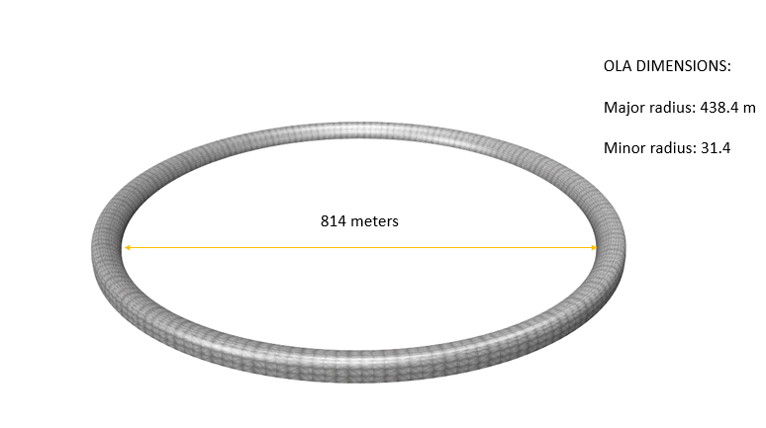**Fig -6: OLA**

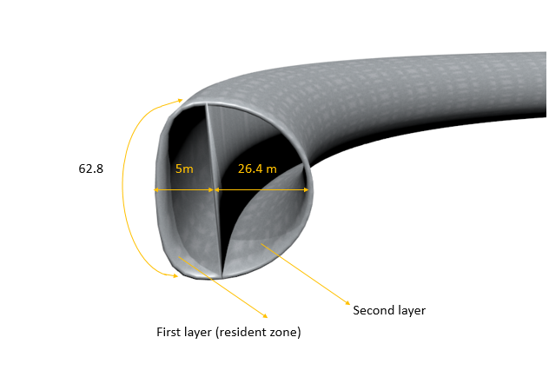

**Fig 7: cross section of OLA**

The humans and all their requirements will be placed in the first layer of the torus, while several other components have been placed in the second layer. The first layer of the torus has been divided into 4 major sectors, these four sectors have further been divided into several minor sectors. Similarly, the second layer has been divided into five sectors. The first and second layers along with their sub units have been mentioned below.

**First layer**

***Four major sectors***

1. Human requirement sector

2. Technical sector

3. Food processing unit

4. Manufacturing unit, desalination unit and biogas plant

***1. Human requirement sector***

1. Residential area: Residents live here.

2. Defecating and bathing zones: Residents excrete and bathe here.

3. Cafeteria: Citizens eat and dine here.

4. Hospital: Residents are treated and diagnosed here.

5. Entertainment sector: Citizens enjoy and play games to provide physical fitness.

6. Football and laser tag: Football and laser games are played here.

***2. Technical sector***

1. Labs: Pioneering and innovative research is carried on by geniuses here.

2. Control Panel: All the activities in HESTIA are monitored by workers working here.

3. Quantum Computer: The brain of HESTIA. Computers process everything in HESTIA.

***3. Food processing unit***

1. Harvest Center: Yield will be stored here.

2. Kitchen: Dishes are prepared here.

3. Milk, cheese and cottage cheese processing unit: Soy beans are processed to form soy milk, cottage cheese and cheese.

***4. Manufacturing unit, desalination center and biogas plant***

1. Cleansing solution manufacturing unit: Manufacturing units to prepare cleansing solutions used in the lavatories.

2. Toilet Paper Manufacturing unit: toilet paper is manufactured here.

3. Laundry: this area Has machines which wash and dry all the clothes.

4. Everyday supplies: Important items required for daily usage are manufactured here.

5. Desalination center: Water purification for re-utilization.

6. Biogas plant: Harvesting electrical energy from feces.

**Second layer**

1. Mini agricultural zone: Few crops have been grown in this zone.

2. Emergency agriculture unit: A few extra crops will be grown here in case any batch is not fit for consumption.

3. Extra storage unit: In case of an emergency we have stored supplies of required materials like food and oxygen inhalers.

4. Park: A walking Path with grass will be made in the second layer.

5. Engineering area: People will implement their ideas, explore and invent in this area

The subunits have been explained thoroughly in the upcoming chapters of the project.

**3.1 RESIDENTIAL AREA**

The residential area is the region where people go to sleep and take rest. This region consists of bunker beds that have been designed to provide comfort and entertainment to the residents.

Each bunker bed houses two residents. The beds will be made of memory foam. The bed will be 230cm in length and 120cm in breadth. The bunker bed in all is 220cm high. The base of the bed will have a space of 100cm for storage purposes, 15cm for mattress thickness, 85cm space between the upper and lower bunker and 15cm thickness for the upper mattress.

One residential area will house 960 people. Each residential area will be divided into four sectors which will house 240 people. Each sector will have 120 beds. These beds are arranged in a pattern to make the sector a square. Each sector will have 10 beds in length with 60cm space between each bed. The breadth of the bed is 120cm and we will arrange 12 beds in breadth. There will be a space of 150cm between each bed. In all, each square sector will be 28.4meters. there will be a space of 6m between each square sector. Therefore, the residential area will be 62.8m in length. As we are aiming in settling 11,520 people, we will be having 12 residential areas.

The bunkers will have a storage capacity of 1.44m3 for each person. Most the supplies will be provided by the settlement itself but residents will still be provided with storage space below their bunkers, just in case.

The residential area will be located in between four other areas. People will from one area will access all these four essential areas.

**3.2 CAFETERIA:**

For humans, consumption of food is important as energy is provided through this. Since a place for consumption is required we have made a separate place where people can consume food. The cafeteria is important part of this project. As mentioned above in the agricultural chapter we have made three different types of sequences to ensure that nutrients are reached to all. The cafeteria is in Ola. The cafeteria is positioned on the lower portion of the Ola torus. The cafeteria is as big as the residential area. By building such a large space for cafeteria this ensures that all the residents are provided food at the same time. The food is provided to people by automated machines that are built into the dispensers. The automated system first tethers with the nanobots of the individual. This makes It easier for the kitchen to make limited amount of food and no wastages occurs. The tables positions are given in the image below. The cafeteria ensures that appropriate amounts of food is provided to everyone. The dispenser has a detector that needs authentication of the individual before provision. Thus, no individual gets food twice the amount of food than required. Also, it avoids a person from not getting any food. The dispenser first displays a message asking the authentication of the individual. Then it tells the individual the sequence that is being provided and shows the comparison nutritional facts of the individual and the sequence that is going to be provided. This sends a signal to the kitchen and the food is passed to the cafeteria via vacuum tubes and hence, provided to the individual.

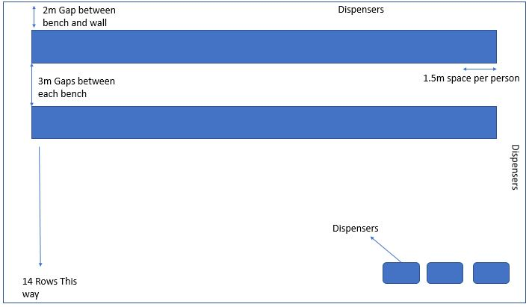

***Fig-8 The cafeteria tables representation***

**3.3 HOSPITAL**

Hospitals are a very important part in our lives in space as well as on earth. It is a necessary component of our lives.

Our hospitals will be in the inner torus. One hospital consists of:

CLINICS: 9

EMERGENCY ROOM: 180 BEDS

INTENSIVE CARE UNIT: 18

OPERATING ROOMS: 9

This is utilized by people of three residential areas. There are 3 other hospitals which are utilized by 9 other areas.

**3.3.1 CLINIC:**

In the long-term survival of human race in outer space, we need to ensure their short-term survival, that is, we need to make sure they are functioning well by monitoring them on a weekly basis.

In the beginning of the project, we have briefly discussed about Nano-bots. Special Nano-bots will be manufactured to monitor internal human activity. This is to ensure short term human survival which will gradually develop into long term survival. These Nano-bots are specially engineered and built to live as a parasite in the humans. But, these bots will not benefit from its host rather the host will benefit from these bots.

These Nano-bots are very small. As these bots are very tiny, the human won’t feel a single thing. They will be made of ceramics. Although these bots will be made of human-safe components, they will still be recognized as foreign substances and our immune system will do its best to suppress them. But, the bots will be made of MATERIALS which are very strong and our bots will be coated with “MATERIAL” so that the body will identify them as their own components.

The bots will be injected into the human body and will flow in the blood system of the human. They will run tiny tests in different parts of the body and identify the problem with it. The human is being monitored without his full attention. These bots collect and store information when necessary. The process is explained in the next paragraph.

In a weekly check-up, astronauts must stand in a small closed part of the clinic. This room will have scanners placed around it and will scan the human body. These signals are received by the Nano-bots and transmit them in a special way. The antenna placed in the room will receive these messages and will pass it on to the computer placed in another part of the clinic will interpret it and the designated doctor reviews this information. The astronaut who was scanned just then will meet the doctor.

In case there are no problems with the human, he will be excused and can return to his daily schedule.

In case there is a minor problem, the astronaut will be asked to consult one of the specialists who are located close-by in one of the rooms.

In case of an emergency or a case which needs immediate attention, the patient will be taken into the emergency room where he will further be treated with better facilities and arrangements.

There are 9 clinics each of whose lengths are 6.2m and 4m in breadth. There are 3 general clinics and 6 special clinics. General clinics consist of full body scanner, general physician and a drug store. There will be a space of 3.2m between three of the clinics.

The special clinics consist of the specialist doctors with dedicated equipment. There are 6 special clinics and 14 doctors will be on rotation. Psycho therapist, ENT, pediatric, orthodontist, allergist, dentist, infectious diseases, micro-biologist, neurologist, surgeon, orthopedic, anesthesiologist, gynecologist and immunologists are the specialists we will be taking aboard our space craft.

There will be 3 drug stores each in the general clinics. They will have all the necessary drugs and medicines in stock. We will carry these from earth and will be rejuvenated in our labs with the help of special tools. Some drugs will also be made from some agricultural plants grown in our space ship.

**3.3.2 EMERGENCY ROOM:**

Emergency room is very vast with 180 beds in total for three residential areas. The patients with minor ailments are brought here and are given better care and are monitored as best as possible. This room provides the best care possible to all the patients.

Each bed in the room is 2.4 meters in length and 1 meter in breadth. This gives them a comfortable feeling. There will be three rooms in total with 60 beds in each of them. There will be a space of 1.2m between each bed and 3m vertical space between vertical rows of beds. Each of the three rooms will be 33m in breadth and 18.6m in length. Each room has a space of 3.2m between them.in total, the emergency room will be 62.8m in length.

The emergency rooms will have cupboards on the top around 1.9 meters above the ground level. These cupboards will contain necessary equipment in the case of an emergency. Nurses stationed near the section will take care of the patient in the case of an emergency. The nurses will be highly trained and equipment will be the best in class. Doctors will visit the patient regularly and understand more about the physical condition of the patient.

If the patient’s problem has been identified, they will be treated. In case an operation is one of the requirements, they will be taken to the ICU and later to the OR.

**3.3.4 INTENSIVE CARE UNIT:**

The ICU is another requirement of a hospital where patients in critical condition are taken care of. The rooms will be equipped with “EQUIPMENTS”. Constant observation by nurses is also seen. The patients will be taken care of by the best doctors in their own respective fields. The ICUs are scientifically designed with color changing walls suited for varied set of patients. Patients will also be provided with necessary equipment to pass the time. With the patient’s approval, they might be given tasks or may continue their jobs if not harmful to their health.

The ICUs will have their own ventilations systems. This is to ensure that the quarantined patients will respire without causing trouble to people outside as well as themselves. This will also come in use when infectious diseases have attacked our citizens.

The ICUs will be in a closed room covered by glass walls. These glass walls may be transparent or not depending on the patient’s wish. These glass walls may appear transparent to the observer outside the room but may not so for the patient inside. The glass walls will also act as a TV which can be remotely controlled as per the patient’s request. The TV will show soothing sceneries to help the patient through the process. The glass will be voice activated, with each request beginning with SOS (superior operating system). These walls will also store any data regarding the patient’s care, reports and a real-time activity monitor. The doctors assisting the patient can access this data any time they visit the patient. The doctor can also explain the diagnosis to the patient with the help of better scans and reports. Better 3D scanners will be used to explain these reports and scans for a better understanding of the problem. If the patient undergoes any trouble while staying in the room, the staff located in the control panel and a few nurses and doctors will receive an automatic alert. This will guarantee the patient’s condition as many deaths take place due to delay in attending the patient. the glass walls will also be linked to the Nano-robots present in the patient. this will further improve the condition of the patient as all safety regulations are taken into consideration.

The ICUs will also consist of tiny speakers located near the patient’s bed which will play soothing music all through the ordeal. The music played can be stopped or modified. The choice of music will be left to the patient but should be approved by the doctor for medical reasons.

There are 18 ICUs for three domes. Each ICU is spacious and comfortable with 6.2m length and 5.4m breadth for each of them. Nine ICUs are located parallel to each of them. There will be a space of 2.1m between ICUs and ER. There will also be 3.2m space between every 3 ICUs.

**3.3.5 OPERATING ROOMS:**

An operating room is also a very important component of any hospital. If a patient has any internal failure which must be treated by a medical operation, it will take place in one of these rooms headed by the best in the field, assisted and observed by next generation doctors.

Operating rooms must be maintained very clean as the smallest problem can be very fatal to the patient. These rooms will be cleaned and sterilized each day. Least usage of water will be assured but cleanliness will be of utmost importance.

The tools which will be used to operate will be sterilized everyday even if they aren’t used the quality of these tools will be superior to assure that there are no tweaks in the operation as safety of patient is very important. The tools which need to be very sharp will undergo tests to guarantee their qualities. Wash basins are kept on one side of the operating room for the doctors to keep their hands clean. The rooms will be spacious and will contain cameras and washing spaces also. The operations will be viewed by different doctors to assure safety of the patient. The doctors will be given special clothes to wear every time they operate to make sure that the safety of patients is not compromised. Separate ventilation systems will be provided for each of these operation rooms to assure safety to all the citizens in and outside the operating rooms.

Just before an operation is going to take place, the patient will be injected with a liquid which will neutralize or destruct the Nanobots in a safe manner to ensure a smooth operation without any bumps on the road to safety.

There will be 9 operating rooms for three residential areas. Each OR will be 6.2m in length and 6m in breadth. Three ORs will make one section. And will have a space of 2.1m between each ICU and 2m between clinics. 3.2m space will be give between each section of OR.

In unfortunate situations where one of our citizens dies, an autopsy will be performed to identify the cause of death even if it is an obvious one. This is to ensure safety of our citizens as we get to learn from the mistakes of our past. We will also become more efficient in the future.

**3.4 ENTERTAINMENT:**

### Entertainment is something that is essential humans require to overcome boredom. But in space we have very little or no entertainment so, we need to find a way to keep our selves entertained and keep our mental state peppy. Hence, we built a separate area for entertainment. We have decided that we will host a clear majority of systems and tech.

**Concept:**

Our main concept is to deliver sheer performance in low electricity demand, and to entertain the people hassle free. We have decided that we will be hosting a main server computer which can handle the tremendous amount of data flow.

**Different forms of entertainment:**

The different type of game we will be using in our space station are: -

* Virtual games
* Soccer
* Grass walking area
* Laser Tag

***3.4.1 Virtual Reality:***

We have used many of the latest technologies such as the virtual reality headsets, smart Gloves, a powerful computer that can handle such large amount of processing (The configuration of this computer will be discussed later), smart boots, and finally a multi directional treadmill for virtual movement of the human body. This makes the user feel he is literally in a virtual world and exploring it! The gaming experience will be immersive. But now we all have one thought in our mind that is, how do not let the user from walking out of the treadmill. We have built a constraint to hold them, a long stand that narrows toward its upper end, it has a small slab above that has a tethering rod hanging which is further connected to the back of their suit. On the base of this stand will be the treadmill that help in virtual locomotion. There are 960 of such stands for one dome worth of people assuming those many people ply in an hour. The gloves (Smart gloves) for motion tracking are just like our winter gloves; They are thin like a fiber and not thick with heavy components lying in it so, therefore the glove will be skin tight and will house all the components that are printed into them (*Reference to a prototype model of smart gloves called Glove One).* The pod is not only capable of being a “virtual reality” pod with a multi directional treadmill in it. the belt on it can be retracted in, and replaced by a panel with lights and kinetic tiles which is a dance floor. The user can stand on this pod with their virtual reality headsets and can dance on it. With the help of kinetic tiles a small but significant amount of electricity can be produced. The entertainment area is in the inner torus. We have arrived at this value by carefully spacing these pods and by adding it up to the area taken by each of these pods.

***3.4.2 Computer:***

We aim to use high performing low energy consumption quantum computers that use liquid cooled CPU and GPU. They usually perform at 100 Petaflop’s per second. the main purpose of using a server instead of a cubicle type gaming is, the amount of power consumption. For example, a gamer playing 7 hours a day consumes 1890 kilowatts per year an average gaming pc will draw about 1400 kilowatt hours per years, if there are 960 such PCs the consumption is about 1.8 kilo watt but with a less performance ability so, it is advisable to use a super computer and use it as a client server and connect the 960 users to their respective terminals. while the quantum computer consumes about 4 megawatts per year. Thus, for energy efficiency we are going to use quantum computers. We are using GPU that support graphical processing when under a quantum computer’s processor. So, we are using almost 526 giga bytes of graphics. The GPU that is VR ready is *NVidia Quadro p5000.* Physical memory of 1 terra byte. This super computer act as the main server PC. Which are connected to the pods using a client pc.

We will be using all hybrid meta materials which are built to last and to withstand high temperatures.

For example, we will be using graphene on PCB or fiberglass PCB to be used on the circuitry systems. Instead of aluminum cooling blocks we can use matrix or lattice materials to cool the system with liquid carbon-dioxide, which is abundant on the mars lunar base. We will also be using holographic and virtual reality to make the gaming experience more intuitive.

### *3.4.3 Soccer:*

### Humans not only need entertainment through virtual games, they also need some amount of physical exercise. Sports like soccer and paintball can be played by the people in this settlement in their leisure time. Paintball is fun and an exhilarating game. People will be provided protection from the fastmoving paintball to avoid any injury, they will also be provided a map of the course to play the game. The map will be constructed with sensors so that in case of any injury the sensors can note the players’ location and see that they are accommodated in the hospital. The paintball map will be long and wide. Soccer may sound impossible to play in space but we have managed to make this possible, with the help of artificial gravity. The soccer field will be made up of a synthetic material called Polyethylene blend. Which gives us artificial grass, so therefore a person playing soccer feels like he is on the real soccer field. The soccer field will be of the same dimensions like a basketball court, 28.4m long and 15m wide. There are 3 such football fields which placed side by side. This targets in both physical fitness and as a part of entertainment. Hence some part of the physical fitness is covered here.

### C:\Users\varu\AppData\Local\Microsoft\Windows\INetCacheContent.Word\Football.jpg

### *Fig 9- Soccer field*

***3.4.4 Grass walking area:***

In addition to these the people in this settlement can also take a walk around the internal torus for a breath-taking view of space. The floor will be built with grass so that the person walking in the turf feels like he/she is in Earth talking a walk in a plush greenery of a garden. There people an also borrow a drone and fly it around the circumference of the settlement. This walk will be in the upper portion of the inner torus. The height of this portion of torus is 4m tall. The red line in the figure below is where the beginning of the walking area for people.

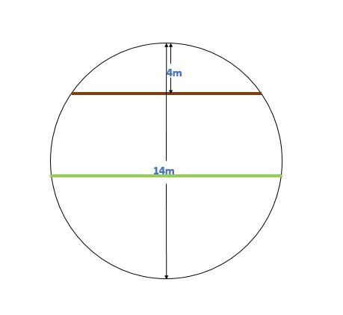

***Fig 10- The walking area***

***3.4.5 Laser Tag:***

laser tag is a game that is fun and exhilarating. People are provided sensory belts that attach to their suits and read the position of the laser pointer. The map is custom built and it can be changeable at the will of the operators. The walls of the map are hologram projection. The laser tag map has multiple sensor that helps in looking for any user that is bumping or walking through walls to avoid unfair a game when the user walks into a wall, the projection turns red and warns the user to move away from the wall. In case of cheating the users’, tags won’t be counted. The game winner will be provided with ETICONS. The laser tag has the same dimensions as the football field. There are 3 laser tag that are placed side by side.

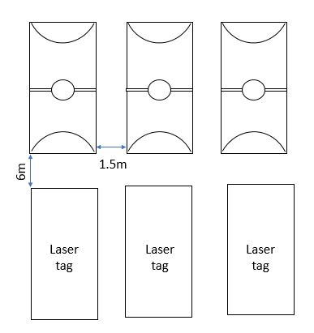

***Fig- 11 Position of the laser tag and football grounds***

**3.5 CONTROL PANEL:**

Control panel is the most important part of this settlement. It monitors everything from the room temperature to the water supply in the agricultural sector and from cabin pressure to plant nutritional values. The control panels are supported by two quantum computers, which will be discussed later. The control panel is in the inner torus, since it makes it easier to route information from the agricultural sector and as the torus is almost in the center of the entire structure information from other parts of the structure can be routed too. It majorly monitors an individual’s physical state and his/her nutritional values. Every individual in this structure will be provided a band that provides access to all the activities (Except the restricted ones). Nano bots that are injected into the blood stream, monitors their fitness levels, it is wirelessly connected to the control panel where the information is stored in the quantum computers. The food preparation is automated and as described in the agriculture section of this, it has three sequences. So, someone needs to see that a person with deficiency of some nutrient is provided. Therefore, the control panel with the help of the quantum computer makes sure that the sequence with richness in a specific nutrient is made for that individual. If an individual’s muscles are losing fitness then, the band notifies them to go and workout. The control panel also keeps track of the amount water that is being used and the amount of water that is being produced. The storage area must be accounted, the total harvest produced will also be calculated by the quantum computer. Soy milk is a substitute for ordinary cow milk, so the amount of soy and soy milk produced must be taken in to account which is looked after by the control panel. The control panel also looks after the security of the structure. All the camera footages are monitored here and the footage of each day will be stored back in the quantum computer’s hard drive.

The quantum computer is very essential as it controls the most of the structure’s systems. It said to have calculation speeds of about of about a *10-quadrillion* *calculation per second*. Super computers are usable but they require a large amount of space and cooling. Hence, we chose quantum computers. They require only space of about 5 refrigerators (Assuming they are about a 60cm wide; *Source D-WAVE)*. These computers run on a 1,000-qubit processor architecture which leads to calculation in a few micro-seconds (*Source Wikipedia*). We are using 2 quantum computers where one is a main and the other is a backup. The data stored in the main will also be replicated in a regular interval to make sure the data in it is up to date. The percentage of accuracy of these computers is 99.99% Hence, they are more reliable in a day to day basis as a large amount of data will keep coming and a large amount of monitoring must be done. The access to the control panel and the quantum computing area is restricted. The quantum computer will be maintained by trained and authorized personnel only. The quantum computer chamber is directly next to the control panel therefore; direct access is provided. The quantum computer needs temperatures that are near to absolute zero for cooling and its chamber must be pressurized to avoid corrupting any data present in it. So, this chamber is separated from the remaining sections of the inner torus. And the processors of the quantum computers are cooled with *liquid oxygen,* which keeps it at near zero value.

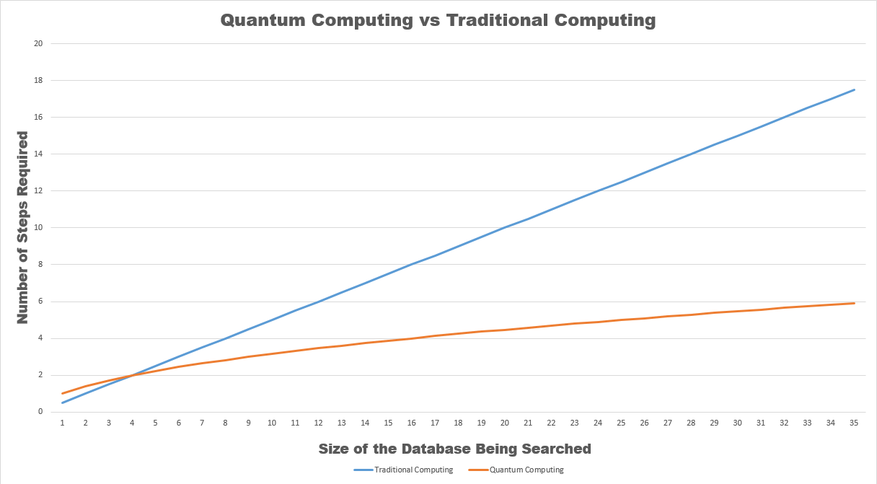

*Fig 12 graph showing steps required to solve a problem during a database search between a traditional computer and a quantum computer.*

From this graph we can easily understand that a quantumcomputer outsmarts an odinary computer that we use in our day to day life. A quantum computer is faster in retriving information from a database so, makes it easier for the control panel engineers to access information faster.

**3.5.1 RESIDENTIAL AREA:**

The residential area control panel will consist of 40 operatives at any time who will run an 8 hour shift for each day. These operatives will continually work on regulating the atmospheric gases, temperature, pressure, angular tilt, TV content and durations, humidity and lighting conditions of the residential areas.

3 operatives will be working for each dome and for avery 9 operatives of the same quadrant, 1 person will be their manager. This way, we will have 36 operatives with 4 managers to monitor their activities.

**3.5.2 MANAGEMENT:**

The managament control panel will consist of 11 operatives at any time who will again run an 8 hour shift for each day. These operatives will continually work on monitoring and regulating the technicians working in each sector of the control panel. They will command and see to that the technicians do their work efficiently.

1 operative will be managing each sector of the control panel. There will be 2 other managers who will monitor the activities of all the other managers.

**3.5.3 SANITARY:**

This sector will consist of 24 technicians and 1 manager. These people will regulate and make sure that the toilets, bathrooms and the dress changing areas in the tubes will be run smoothly. There are in total 2880 lavatories, 160 sterlization and 80 bathing zones. Each technician will manage 120 lavatories, 80 sterlizing areas and 40 bathing zones such that they function properly without any problems.

**3.5.4 ENTERTAINMENT AREA:**

This sector will consist of 10 technicians. These people will regulate the sports and entertainment areas. There are 88 sectors in total to manage. Each person will manage around 9 sectors as not much problems will arise.

**3.5.5 TECHNICAL:**

This sector will consist of 25 technicians. Whenever there is a problem with one of the computers or any other electronic gadgets, they will be called on to find a solution for it. With standard cubicle measurements. They will receive a message whenever they are needed.

**3.5.6 BIO GAS:**

This sector will consist of 10 technicians. These technicians are scientists and engineers who will monitor and regulate anything related to the bio gas plants. Temperature, humidity, vuccuum, pressure, mass, water regulation and fertilising area. They will also monitor gas production and usage.

**3.5.7 LAB:**

This sector will consist of 24 technicians. These technicians are retired or physically disabled experts in certain field who will monitor the progress and accomplishments of the scientist working in the laboratories. These scientists will help and also manage the laboratories. Each scientist will manage 1 laboratory. There will be 1 manager to monitor all of these people

**3.5.8 KITCHEN:**

This sector will consist of 24 technicians. These technicians will be the main heads behind the food and kitchen sector. They will monitor the food sequence given to each person, amount of food provided for each person, temporary storages and machines used in preparing the food. Each kitchen will be maintained by 8 technicians. They will also monitor the vaccuum tubes used in the transportation of the dishes. There will be 1 manager to monitor all of these people.

**3.5.9 WATER MANAGEMENT:**

This sector will consist of 24 operatives. These operatives will be the main heads behind the water regulation, consumption, transportation and management. There will be mathematicians and engineers to brain storm the water mangement systems and construction and maintenance of the transportation of tubes. All of these will be maintained by 24 technicians and 1 manager.

**3.5.10 HOSPITAL:**

This sector will consist of 280 operatives. These operatives will be managing and completing all the needs of the patiemts located in the hospital area. There will be 70 operatives working for each quadrant. These 70 operatives will manage the clinic, ICUs, ORs, drug stores, ERs and scanners. They will monitor the health of the patients real time for ICU patients as well as some patients located in the ER as they may be prone to certain prblems which need immediate attention. If the patient’s stats are coming down, they will immediately send messages to the nurses and doctors for immediate attention. They will help the patient for any need.

**3.5.11 AGRICULTURAL STORAGE AREA:**

This sector will consist of 10 operatives. They will make sure that the yield stored in these places will be fresh and ready for consumption. They will maintain optimum temperature, humidity, lighting and music. These factors will play a mojor role in keeping these foods fresh for consumption. This sector will need very less attention other than a quick glance at the stats.

**3.5.12 CULTIVATION AREA:**

This sector is the most important one. There will be in total 30 technicians working here. They will make sure that the crops grow in an optimum temperature, humidity, ligthing, music and also the water and nutrients supplied is to the very last detail. There are two divisions in the above sector. The mini agricultural sector will be managed by 12 operatives and other 18 operatives will manage the major agricultural sectors. These operatives will be consisting of scientists and mathematicians who will work to make the cultivation effiecient.

|  |  |
| --- | --- |
| SECTOR | OPERATIVES |
| RESIDENTIAL AREA | 40 |
| MANAGEMENT | 12+2 |
| SANITARY | 24+1 |
| AGRICULTURAL STORAGE | 10 |
| CULTIVATION | 30 |
| ENTERTAINMENT | 10 |
| TECHNICAL | 24+1 |
| BIO GAS | 8 |
| LAB | 24+1 |
| KITCHEN | 24+1 |
| WATER MANAGEMENT | 24+1 |
| HOSPITAL | 280 |
| TOTAL | 517 |

The control panel will not be divided into independent segements housing different sectors of control panel but will be a common work place. All the workers work in the same place but will be differnetiated into their own sectors.

Each worker will have his/her own cubicle. Each cubicle is 1m broad and 0.8m long. There are 27 cubicles on one side of a section. Each section will have 54 cubicles. Each section has a space of 1m between each of them. We need to house around 500 workers, hence we need to have 10 sections. Each side of the walking area will have 5 sections. Either side of the control panel will be 15m long.

The cubicles will be colured differently according to the sector they are working in. this is to avoid confusion between different workers and their work place.

The control panel can house 540 workers where as the upper limit of our requirement is 502 workers. The leftover spaces will be used by other residents and scientists. These other spaces will also come in handy if in case of an emergency.

**3.6 HARVEST CENTER**

We do not get yield from crops every day and neither do we consume all the yield in just a single day. Since we have tons of yield, we need to conserve and store it. We hence need the harvest center to do this job for us.

The harvest center stores, conserves and keeps the yield fresh for consumption. This is highly necessary as we need to consume fresh foods to stay healthy. If not, we may fall ill or may not benefit from those foods.

We need to keep a few things in mind when we need to store food so that they don’t decompose or go into waste. For the food to stay fresh, we need to store them in a cool, dry and spacious place. We also need to make independent compartments for easy identification.

***3.6.1 REFRIGERATION***:

The stored food rot only because of the microbial activity taking place on them. If we reduce the temperature, the microbial activity slows down, possibly stopping it altogether. This way the food does not get spoilt and can be preserved for a long time. The refrigerator also keeps the room dry as the water is evaporated while the heat exchange takes place.

The coolant used will pass through a de-compressor. The sudden drop in pressure will cool down the liquid. When this cool liquid passes over the storage room, it gains heat from it dropping the temperature of the room. It is then made to pass through a compressor and the increase in pressure increases the temperature of the liquid. It again passes through the de-compressor repeating the cycle all over. The tubes are separated from each other by an insulating material so that heat exchange does not take place between them.

***3.6.2 MEASUREMENTS***:

They will be accessible to only few people. The storage space for each crop is leniently provided as improved air circulation among the yield preserves these articles for a longer time. It can also accommodate much more yield than what fits necessary. The storage space of each vegetable and fruit is specified in the table given below.

The kitchen staff can access the storage space as and when necessary. The harvest center is located on either side of the walking area. Each side of the harvest center will have 20 storage areas. There will be 5 storage areas length wise and 4 storage areas breadthwise. Each of these areas will be a square of 6.4m side. They will be able to hold 1638.4m2. in total, the length of the harvest center on one side of the harvest center is 36m. between each storage area, there will be a space of 1m either side.

When the harvest eventually exceeds the limit, another division will be made in the storage areas to hold more yield.

There will be two more storage spaces, for agricultural purposes and others. The agricultural space will contain some of the better yield of the harvest for plantation of the next season. It has about 8 meters for storage. Not all harvest will be of exceptional quality, therefore we have one more storage space for the bad harvest. Experts in botanical field will assess these items and decide their future. The may be used to cook, they may be used as seeds, they may be used for different test in our laboratories or they may be thrown off into the bio gas plant. Overall, none of the harvest will be put into waste and all of them will benefit our space station in some or the other way.

**3.7 KITCHEN**

The crops grown in PAN cannot be eaten raw. Hence, we have a kitchen to prepare dishes using these ingredients and make them edible and striking so that our citizens can enjoy and benefit from them. The crops we will be growing are very carefully chosen to benefit everyone in any way possible. We will be trying to make them as delicious as possible so that they can enjoy them as well as gain from them.

We have made three different menus or sequences so that everyone is benefitted in all possible ways. The sequences are as follows:

|  |  |  |  |
| --- | --- | --- | --- |
| **TYPE/SEQUENCE** | **SEQUENCE 1** | **SEQUENCE 2** | **SEQUENCE 3** |
| **CARBOHYDRATE** | Wheat | Potato | Brown Rice |
| **FATS** | Cheese | Groundnut | Cottage Cheese |
| **PROTEINS** | Corn | Beetroots | Milk |
| **VITAMINS** | Carrot | Finger Millet | Sweet potato |
| **MINERALS** | Tomato | Bitter Gourd | Cabbage |
| **FIBER** | Beans | Peas | Barley |
| **TOTAL CALORIE** | 3050 | 3300 | 2550 |

After the harvest is completed, they will be transported to the storage center which is in the inner torus. But the food is still raw and must be prepared for human consumption. From here, the harvest is taken to the kitchen and stored in another smaller room to avoid frequent visits to the storage center. The storage facilities of the kitchen keep a cool condition in the room to avoid decomposition or oxidation of the yield.

Whenever necessary, kitchen staff will visit the store room and take all the necessary items and head to the preparation center. The room will be divided into 5 identical tables where the dishes are prepared.

The table is in the form of a cuboid which is 4 meters in length, 1 meter in breadth and 1 meter in height. The height of the table contains the cleaning and processing units as well as the packaging units. The table consists of two preparation areas and in the middle of the table, a gap is provided for the chef to add finishing touches to the food.

Fig-13:

1.6m

4m

1m

1.6m

0.8mmmmmmmmmmmmmmmmmmm mm

VERTICAL VIEW OF THE TABLE

PREPARATION

AREA

PREPARATION

AREA

FINISHING

TOUCHES

Fig-14:

1m

4m

1.4m

1.4m

1.2m

CLEANING AND

PROCESS

CLEANING AND

PROCESS

PACKAGING

HORIZONTAL VIEW OF THE TABLE

The yield is first taken to the cleaning unit. Here, the staff deposits the yield. He then presses a button on the machine indicating the type of food to be cleaned. After getting the cleaned product, in case it needs some other modifications, he puts it through the processing unit and indicates the type of food and appropriate modifications needed to be done on it. After he obtains the product, he takes it and deposits it into a machine on the preparation area indicating the type of dish to be prepared. The machine gives the output which will then be reviewed by professionals who will later add finishing touches to make it look beautiful and tastier. After this process, the finished product will be packed. As and when the breakfast time arrives, the packaged product will be transported with the name of the consumer to avoid confusion. The packed dish will be put in a personalized metal box with the dome number and the name of the consumer on it. There will be many vacuum tubes located around the room to ease transportation of the dishes kept in the metal box. Specific buttons respective to the metal box will be pressed indicating the location and name of the consumer. All the dishes will be in solid form.

**Fig-15: kitchen**

0.75m

0.75m

1m

1.5m

1.5m

1m

1m

7m

11.5m

KITCHEN

The kitchens will be located on either side of the walking area. There will be two kitchens in one side of the inner torus. There will be 5.4m space for temporary storage. On one more side of the torus, there will be another kitchen with 2.7m space for temporary storage. Leftover space of 14.2m will house the quantum computers.

**3.7.1 MENU:**

**SEQUENCE 1:**

|  |  |  |  |  |
| --- | --- | --- | --- | --- |
| **BREAKFAST** | **LUNCH** | **SNACKS** | **DINNER** | **DESSERT** |
| CARROT AND CORN NUTRI BAR | MINI PIZZA | CORN ON THE COB | BLANCHED BEANS | CARROT HALWA |
| CARROTS, CORN, WATER, STEVIA | WHEAT FLOUR, TOMATO, CHEESE | CORN | BEANS | CARROT, STEVIA |

**SEQUENCE 2:**

|  |  |  |  |  |
| --- | --- | --- | --- | --- |
| **BREAKFAST** | **LUNCH** | **SNACKS** | **DINNER** | **DESSERT** |
| CUTLET | RAGI BALLS | TOASTED GROUND NUTS | FRIED BITTER GOURD AND BEANS |  |
| POTATO, BEANS, | RAGI, STEVIA | GROUNDNUTS | BITTER GOURD, BEANS |  |

**SEQUENCE 3:**

|  |  |  |  |  |
| --- | --- | --- | --- | --- |
| **BREAKFAST** | **LUNCH** | **SNACKS** | **DINNER** | **DESSERT** |
| BOILED SWEET POTATOES | FLAVOURED RICE | ICE CREAM | SALAD | BEER |
| SWEET POTATOES | BROWN RICE, CHEESE | MILK | CABBAGE | BARLEY |

Water and other ingredients will be used as necessary. The dishes will also contain special taste enhancers to boost the taste of the dishes.

The temporary storages will be located right next to the kitchens. The storage areas are crafted to hold 25% of one season’s yield. The storages will hold all the vegetables and fruits. It is located right next to the kitchen to avoid frequent visits to the harvest center and diminish the pressure of holding all the crops in only one area. The lengths are accurately measured to hold more yield than necessary. The lengths are given below:

Each of these temporary storages will be 2.7m in length and 7m breadth.

**3.8 LABORATORIES**

In the modern world where the earth evolved from cell phones to smart phones within a few years, we owe it all to research. Without the scientists and engineers, we would not be at the stage we currently are in. research can take us very far in very less time; and hence making that as our motto, we have dedicated 24 laboratories for research and development. This will help us in the long run as we do not intend to leave HESTIA in just a few years.

The laboratories will be equipped with the state of the art equipment, best in the field scientists and will be assisted by quantum computers to ease their simulations and calculations.

**PHYSICS**:

1. ELECTRO MAGNETIC: improving the applications of electronics combined with magnetic powers.
2. ASTRO-PHYSICS: observation of the universe for wider applications in humanity.
3. MEDICAL PHYSICS: benefitting the field of medicine with a touch of physics in it.
4. OPTICS: improvement in communication media and other wide variety of applications.
5. CRYOGEN/NANO TECHNOLOGY: low temperature studies combined with small scale particles in our everyday life.
6. LASER PHYSICS: understanding the universe with the help of lasers in quantum mechanics.

**CHEMISTRY:**

1. INORGANIC CHEMISTRY: improvement in usage and implementation of different elements and their properties.
2. ORGANIC CHEMISTRY: discovery of newer compounds to benefit humanity.
3. PHYSICAL CHEMISTRY: physical applications such as quantum chemistry, statistical chemistry for better understanding of the observable universe.

**BIOLOGY:**

1. BIOLOGICAL PHYSICS: intends to make the living environment much more suitable.
2. BIOLOGICAL ENGINEERING: improvement of engineering products in the field of biology.
3. BOTANY: research on plants for improved variety on different bases.
4. GENETICS: modifications in genome sequences for human benefits.
5. THEORETICAL BIOLOGY: modelling of biological processes using mathematical applications.
6. STRUCTURAL BIOLOGY: research on the molecules involved in biological processes.
7. PHYSIOLOGY: modifications in human parts and improvements related to the functions.
8. MICRO BIOLOGY: research on microbes and their benefits to human kind.
9. BIO CHEMISTRY: improvement in the chemical processes with the human body.
10. ASTRO-BIOLOGY: involves in hastening the evolutionary processes of human beings.

**OTHERS:**

1. ENGINEERING (3): applications of research into real live environments.
2. MEDICAL (2): improvements in the varied field of medicine.

Each lab will be of 14.2m breadth and 7m long. There will be two labs in each section. Each section will have a space of 1.5m between each of them. There will be 12 labs on each side of the torus. The total length of one side is 49.5m long.

**4.0 POSEIDON**

Poseidon is the outermost torus of the space settlement and is humungous in size. The outermost torus has been named after the Greek god of the sea ‘Poseidon’ as this torus is mostly filled with water. Several sections of the torus will be open space from where the people can enter the interior of the settlement after reaching the docking station, but comparatively water is the main component of this torus. This torus is completely covered with solar panels and harvests a massive amount of solar energy.

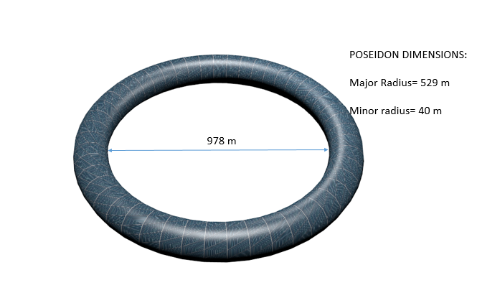

**Fig-16: Poseidon structure**

**4.1 WATER MANAGEMENT**

Water is a scarce resource in space and it must be handled and utilized with care. But water won’t be a big issue for us, as we will be transporting a large quantity of water to the space station, the water transported to the space station will be sited in a torus and this torus is filled with water. The torus in which the water will be stored has been named after the Greek god of the sea “Poseidon”. There will also be a regular supply of water which will be transported from the moon’s surface. This water will be extracted, purified and transported to the space settlement from a lunar base that has been constructed on the moon’s surface. Water on the moon’s surface is present in the form of ice and is present in the shadowed regions of mars. The shadowed region is located at the south pole of the moon; the lunar base will use the water in this region to regularly refill the water tori.

**5.0 LIFE SUPPORT**

**5.1 HUMAN FACTOR**

As mentioned in the beginning, Hestia is a space settlement for 11,520 people. But there will be different age groups with different compositions. On Hestia, we have divided the people mainly into four groups. The first group will consist of children and teenagers from the age group 0 to 18 years, the second group consists of bachelors from 19 to 32 years, the third group consists of middle aged people from 33 to 56 years and finally the fourth group consists of the elderly from 57 years onwards. The composition of each of these groups is given in the table below.

|  |  |  |  |
| --- | --- | --- | --- |
| s no: | Group | age | percentage |
| 1 | Children and teenagers | 0-19 | 12% |
| 2 | bachelors | 20-32 | 34% |
| 3 | middle age people | 33-56 | 46% |
| 4 | Elderly | 57 onwards | 8% |

The number of middle aged people are comparatively more because we are bringing the elite members of the scientific society to make Hestia more advanced and a better place to live in, the number of male and female in each group will be proportionate. Hence the number of people in each group and the composition of male and female is given in the table below.

|  |  |  |  |  |
| --- | --- | --- | --- | --- |
| s no: | Group | no of people | no of male | No of female |
| 1 | Children and teenagers | 1383 | 691 | 692 |
| 2 | Bachelors | 3916 | 1958 | 1958 |
| 3 | middle age people | 5300 | 2650 | 2650 |
| 4 | Elderly | 921 | 460 | 461 |

|  |  |  |  |  |
| --- | --- | --- | --- | --- |
| S no: | Gender | Youngsters | Married | Single |
| 1 | Male | 691 | 2940 | 2128 |
| 2 | Female | 692 | 2636 | 2433 |

The number of married men, married women, single men and single women has been given in the table below

**5.2 SANITATION**

Sanitation refers to maintaining a clean, hygienic and germ free environment by preventing humans from getting in contact with waste or discarded material which pose a threat to their health. When we talk about waste or discarded material we refer to human excreta, urine, agricultural waste and sewage waste.

Providing sanitation to people requires a system that takes care of all the issues relating to sanitation. “The experience of the user, excreta and wastewater collection methods, transportation or conveyance of waste, treatment, and reuse or disposal all need to be thoroughly considered”.

*(Source:* [*https://en.wikipedia.org/wiki/Sanitation*](https://en.wikipedia.org/wiki/Sanitation)*)*

All these factors have been taken under consideration and we have made a specially designed sanitation system where all the waste will be reutilized so that the amount of waste produced at the end would be very less. Sanitation is a must and will be maintained with specifically designed urine separation toilets or USTs as well as a sewage system which will direct all the excreta and urine to separate regions. The sewage system will be placed below the base where people will be walking. The dimensions and arrangement of the sewage system will be explained in the upcoming chapters of our project.

All the defecating stalls are placed inside the inner tori, the area of each of these lavatories has been calculated accurately. Each of these defecating zones will be consisting of one UST and the design of the UST’s will be explained in the upcoming chapters of the project. All the defecating areas are separate and anyone can use them irrespective of their gender, they are also very spacious and no discomfort will be felt by any resident.

Urine is a liquid that contains 95% water and other components like urea, creatinine, sodium, potassium, calcium and other organic compounds. The urine obtained from each person will be used for various purposes. First, the urea present in the urine will be extracted and used for agricultural purposes. The urea will be supplied for the crops as a fertilizer and is a rich source of nitrogen. Urea contains 46% nitrogen and is one of the best natural fertilizers known to mankind. The water present in the urine will further be used for drinking and various other purposes. A human produces an average of 1.25 liters of urine per day. From this 1.25 liters of water we can purify 90%, which means that we can recover 1.125 liters.

***Therefore, the amount of urine produced in the space station per day would be equal to 11,520 x1.125=12960, hence 12960 liters of purified water can be obtained from urine alone. This water will later be utilized for taking a shower or as drinking water*.**

The processes used for separating the urea and other salts from water will be explained in the upcoming parts of the project.

The excreta obtained from humans is also very useful and will be used for producing energy in the form of biogas. The excreta could also be used as a fertilizer for the crops in the agricultural zone. The excreta cannot directly be used as a fertilizer; first the toxins and unwanted content must be removed from the excreta and then it can be utilized as a fertilizer for the crops. Since we are using aeroponics not much fertilizer is required, hence the feces will be deposited in a biogas plant to produce energy. Water is a scarce resource in space so it must be handled and utilized with care. This is the reason why anal cleansing will take place with a minimal amount of water and toilet paper.

Another aspect of sanitation includes bathing and keeping our body germ free. To be hygienic and germ free we must maintain a clean body. For this purpose, we will be sterilizing the residents twice a day, they would also take a bath twice a month. The inhabitant’s body will be sterilized once in the morning after he has finished his work out in the gym and once again in the night before going to sleep. When we talk about sterilization we generally refer to killing any germs or pathogens present on our body. For sterilization and bathing there will be separate stalls placed in the space settlement. The number of sterilization stalls will be more than the bathing stalls since the residents will be sterilized more frequently.

***5.2.1 Procedures required for reutilization of urine***

The urine obtained from the people cannot directly be used as a fertilizer nor can the water present in it be used for drinking. This is the reason why urine must be separated into its various components and each component will serve its purpose. The urine obtained from the people will first be transported to a region called the desalination center. In the desalination center, salts present in the urine will be extracted and in those salts urea will be transported to the agricultural zone. In the desalination center a process known as forward osmosis will be utilized to separate the salts from water. We have chosen forward osmosis rather than reverse osmosis or Nano filtration because this technique requires less energy to purify water.” Generally, processes such as RO and NF require a pressure between 600 to 1000 psi to separate the salts from water”.

*(Source:* [*http://www.google.co.in/patents/US6849184*](http://www.google.co.in/patents/US6849184)*)*

This kind of pressure can only be achieved by high energy consuming systems. Hence forward osmosis has been chosen over other desalination processes. In forward osmosis, a semi permeable membrane is used to separate the salts just as in reverse osmosis but the driving force involved here is osmotic pressure, due to this less energy consumption levels have been achieved. After the salts and water have been separated, the water obtained would be transported to the outer tori where the entire mass of liquid is present. Therefore, urine has been completely utilized.

***5.1.2 Dimensions of lavatories, sterilization zone and bathing zone.***

The defecating zone, sterilization zone and bathing zone will be placed in the inner torus. All the stalls in these zones have the same dimensions. Each defecating stall is a cubical and has a length of 1.75 meters and breadth 1.5 meters along with a height of 3 meters. Similarly, the bathing stalls and sterilization stalls have the same dimensions. The inner torus will be divided into three lanes. The first lane will consist of the defecating zone. The second lane will be a 6 meters wide walking area. The third lane will consist of the bathing zone and sterilization zone. Each residential area will have its own defecating zone, sterilization zone and bathing zone.

Now we will be explaining about the arrangement of the defecating stalls for each residential area.

There will be 240 defecting stalls for each residential area. The first lane will consist of these defecating stalls and will further be divided into several rows. In each row, there will be 16 defecating stalls as shown in the figure. There will be 15 such rows and a gap of 1 meter will be left between each row.

The third lane is an exact replica of the first lane. But there will be 160 sterilization stalls and 80 bathing stalls, since the people will be sterilized more frequently the number of sterilization stalls is more in number. There will be 12 such residential areas. Hence, there will be 12x240= 2880 defecating stalls in total throughout the settlement. Similarly, 1920 sterilization stalls and 960 bathing stalls will be placed throughout the settlement.

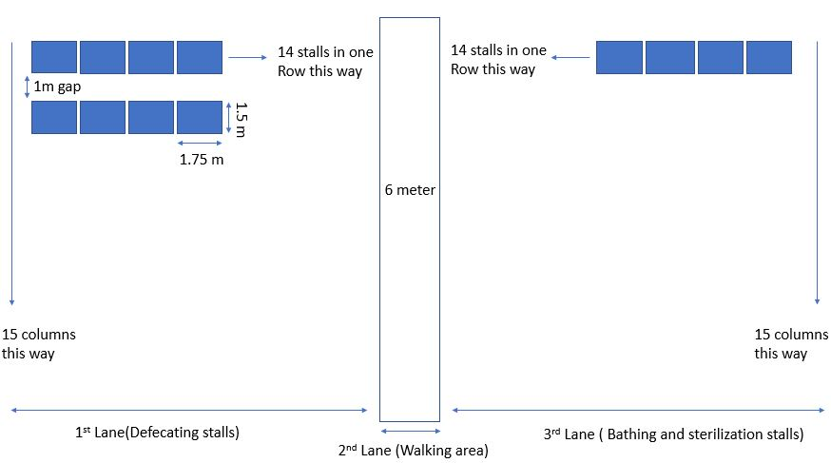

***Fig-17: representation of the arrangement of the stalls***

***5.2.3 Urine separation toilets***

The urine separation toilets or USTs have been designed to make it convenient for the separation of urine and excreta, the urine separation toilets are like the urine diversion dry toilets. To completely understand the concept of USTs we must first go through the mechanism taking place in the urine diversion dry toilet.

A urine diversion dry toilet or UDDT is a toilet which has been divided into two components to keep the excreta and urine separate from each other. The front portion of the UDDT will consist of the urine collection unit or the place where the people will urinate, it is a small region and the urine will travel through a pipe to some other area so that it can be processed or thrown away. Behind the urine collection unit is the second portion and the place where people will excrete, the excreta will directly be stored under the toilet in a pit. After defecation, people will spread soil or ash over the excreta to avoid a bad odor. Sometimes there is also a third hole for anal cleaning or a separate space is reserved for anal cleaning. The main advantage in a UDDT is that there is almost no usage of water except for anal cleaning.

Now we will be discussing a new form or version of the UDDT, in this version there will be two components as usual but the excreta will not be stored under the toilet in a pit but rather be transported to the biogas plant through a vacuum. The second component of the UST will be coated with a super hydrophobic solution called “*NEVER WET”. NEVER WET* is water resistant, thus after defecation the feces will not get stuck on the side walls of the second component.

*(Source:* [*http://www.neverwet.com/*](http://www.neverwet.com/)*)*

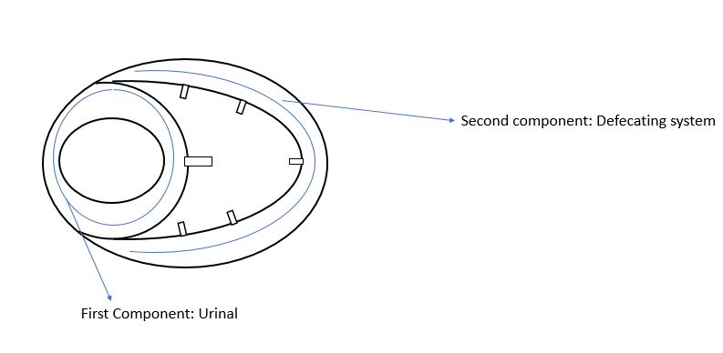

***Fig 18: urine separation toilets***

There is also a third change in the new version of the UDDT and it will be consisting of small flush systems surrounding the upper interior of the second component as shown in the figure. These flush systems spray 80 ml of cleansing solution in repeated successions to remove any pathogens that might cause bacterial infection. In this way, the UDDT has taken a new form and has been named as the UST or urine separating toilets. For anal cleaning, there will be a small pipe that protrudes from the back of the second component as shown in the figure below.

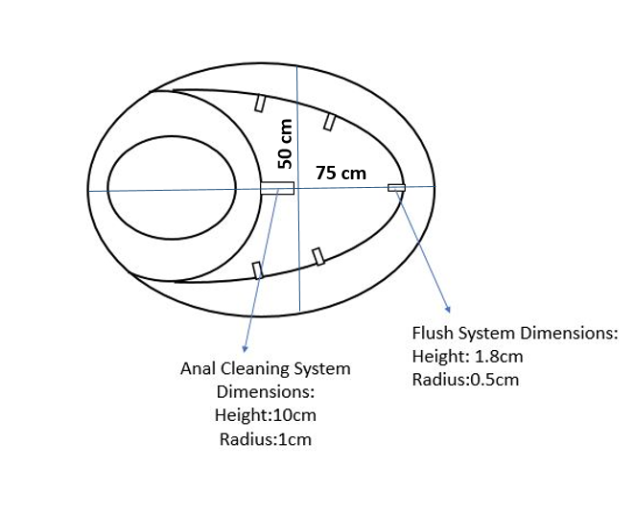

***Fig 19: Dimensions of the urine separation toilets***

This pipe will spray 100 ml of water to wash off any residual feces present inside the anus, there will also be toilet paper present in the defecating area so that the people can wipe off the water present in the anus after anal cleaning. The toilet papers will be made from corn fiber and a separate manufacturing unit will be constructed for production of toilet paper and cleansing solution (disinfectant used in second component to remove any pathogens remaining on the surface).

***5.2.4 Mechanism involved in the anal cleanser***

The anal cleanser is required for cleaning the anal region and is a pipe that protrudes from the back of the second component of the UST as shown in the figure. The anal cleanser will be supplied with 100 ml of water after every wash, it will also be elevated at an angle of 45 degrees so that the water will wash of the residual feces in the anal region meticulously. The anal cleansing pipe will be connected to another pipe that supplies water to it. The anal cleanser is a cylinder with a height of 10cm and a radius of 1cm. The anal cleanser will spray water at a velocity which will not wound the anal region, for turning on the anal cleanser a person must press a switch, this switch will open a valve and the water will come out of the anal cleansing pipe.

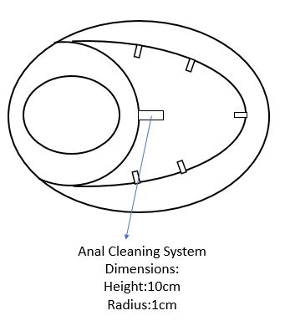

***Fig 20: Dimensions of anal cleansing system***

***5.2.5 Mechanism taking place in the flush system***

First, a cleansing solution container is kept behind the UST to give a regular supply of disinfectant after a person has defecated. A pipe will be connecting the cleansing solution container to the pipe that supply’s water to the Flush system. The cleansing solution container consists of isopropyl alcohol which can be used as a disinfectant. The flush system will be provided with 70 % solution of isopropyl alcohol in water. Therefore, out of 80 ml of solution, 56 ml of isopropyl alcohol and 24 ml of water will be supplied to the flush system after one person has defecated. This will be sprayed on to the surface of the second component of the UST, thus efficiently removing the pathogens that cause bacterial infection. There will be five small sized flushes as shown in the figure below and each flush will be spraying 16ml of the solution.

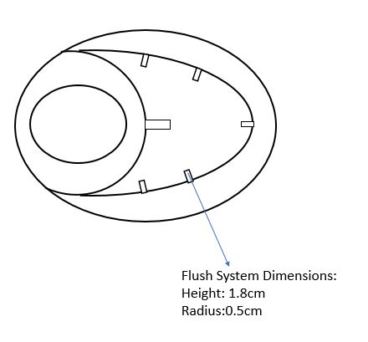

***Fig 21: Dimensions of flush system***

These flushes are very small cylinders with a radius of 0.5cm along with a height of 1.8cm and the velocity at which these flushes spray the water is 2.8 m/s.

After a person completed his anal cleaning he must press a button on the cleansing solution container which will dispense exactly 56ml of isopropyl alcohol, we can do this because we have installed a microchipped processor such as a “raspberry pi” that will be programmed to give exactly 56 ml of isopropyl alcohol and 24 ml of water per flush. These microchipped processers are in turn controlled by a quantum computer that are located at the control panel.

***5.2.6 Sewage system***

A sewage system generally consists of a network of pipes and pumps that help in transporting any discarded material for its treatment. In our space settlement, the sewage system is essential for transporting the feces and urine to separate regions and for transporting water from the water tori (POSEIDON) for anal cleaning.

***Sewage system for defecating zones***

The UST has three pipe lines as shown in the figure below, the first pipe line is the one transporting the urine to the desalination center and the second pipe line transports the feces to the bio gas plant. The third pipe line serves two purposes; the first purpose is that it provides water for anal cleansing and the second purpose is that it provides water for the flush system. These three pipes are in turn connected to three main pipelines that transport the various discarded material to their respective treatment zones. The main pipelines connect all the defecating stalls that are in one lane.

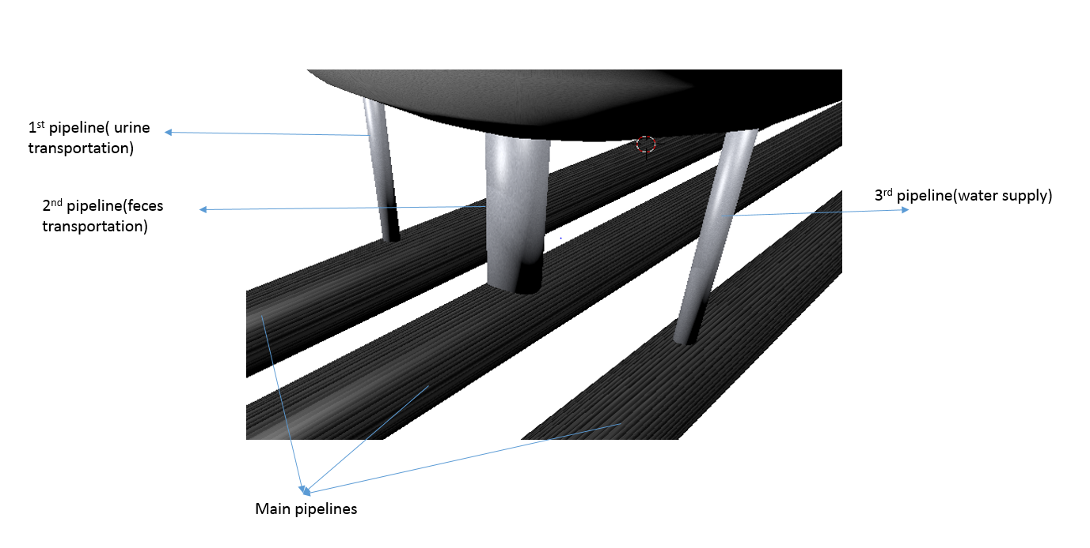

***Fig 22: Arrangement of pipes for the Defecating stalls***

***The dimensions of these pipelines have been given in the table below.***

|  |  |  |
| --- | --- | --- |
| *Pipeline* | *Radius* | *Height* |
| ***1st pipeline*** | ***1.8 cm*** | ***40 cm*** |
| ***2nd pipeline*** | ***5 cm*** | ***40 cm*** |
| ***3rd pipeline*** | ***1.8 cm*** | ***40 cm*** |
| ***Main pipelines*** | ***8 cm*** | ***Extends throughout the inner torus.*** |

***Sewage system for bathing and sterilization zones***

The bathing stalls will have only one pipe line for each stall that transports the water to the shower head present inside the bathing stalls. This pipe line is in turn connected to a main pipe line that transports the water from the water tori, the main pipe line connects all the bathing stalls in one lane. Similarly, the sterilization stall also has only one pipeline for each stall. This pipe line is connected to a main pipe line that transports the water from the water tori, the main pipe line connects all the sterilization stalls in one lane.

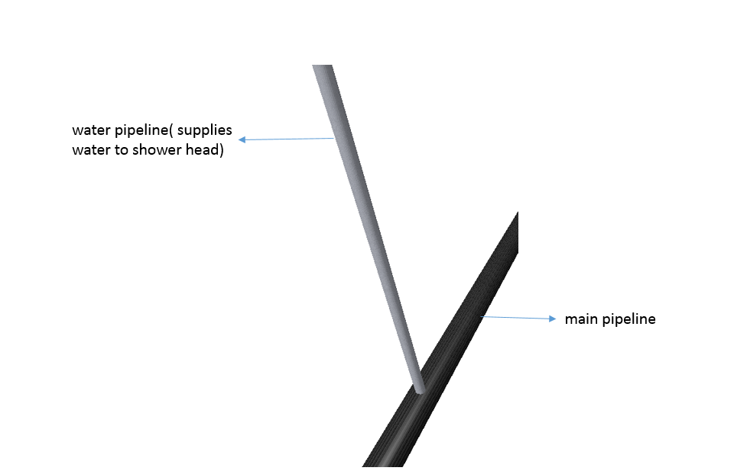

***Fig 23: Arrangement of pipes for Bathing and Sterilization stalls***

***Dimensions of these pipelines have been given below***

The dimensions for the pipelines in the sterilization zone and bathing zone are the same.

|  |  |  |
| --- | --- | --- |
| *Pipeline* | *Radius* | *Height* |
| ***Water pipeline*** | ***2.5 cm*** | ***2 m*** |
| ***Main pipeline*** | ***8 cm*** | ***Extends throughout the inner torus.*** |

**5.3 ATMOSPHERE**

The atmosphere is a very important component of the biosphere that makes life possible on earth. Therefore, we must provide a suitable atmosphere for the people living on the space settlement.

As conveyed above people cannot live without a suitable atmosphere. Thus, Hestia’s atmospheric composition is like that of earths consisting of 78% nitrogen 21% oxygen and 1% other gases which include argon and carbon dioxide. Now we will be discussing about the atmospheric pressure on the space settlement.

In simple terms, the pressure exerted by the weight of air on any object is called atmospheric pressure. People cannot handle high or low atmospheric pressures; thus, the atmospheric pressure of earth must be replicated onto the space settlement.

Since the composition of the atmosphere in the space settlement is like that of earths, the same amount of atmospheric pressure will be acting on the residents’ body. The atmospheric pressure on earth is 14.696 psi and this amount of pressure will be acting on the residents’ body on the space settlement.

**5.3.1 Oxygen**

Oxygen is a very important element and without it, life would be impossible on the space settlement. Plants use carbon dioxide in the process of photosynthesis for making their food, during this process they release oxygen, and this oxygen will be used for respiration. The oxygen released by the plants would be provided to the residents through air vents.

**5.3.2 Fire detection and suppression**

Fire breakouts are dangerous and can prove to be fatal. Therefore, their detection and suppression is very important. Automatic fire suppression systems will be installed in the settlement. These systems are very accurate and will detect any fire and take the measures required to suppress the fire. There will not be any human interference and these systems will be installed all over the settlement to avoid any fire breakouts. The extinguishing agent involved in the fire suppression system is a condensed aerosol, therefore we will be using automatic condensed aerosol suppression systems or ACASS. The ACASS will be insulated with a layer of Aerogel to make it fire resistant.

Condensed aerosol suppression systems dispense a condensed aerosol which consists of very small solid particles and gaseous matter to extinguish a fire. “The condensed aerosol micro particles and effluent gases are generated from an exothermic reaction; these particles remain in vapor state until they are discharged from the device. They are cooled and condensed in the device and then are released as solid particles”.

<https://en.wikipedia.org/wiki/Condensed_aerosol_fire_suppression>

**5.3.3 Mechanism involved in the fire extinguishing system.**

Potassium carbonate (K2CO3) is formed from the thermal decomposition of the solid aerosol present in the system. These solid particles of potassium carbonate are very small with a radius less than 2.5 microns, when these particles meet the flame the decomposition of potassium carbonate takes place which gives raise to potassium radicals (k+). These radicals of potassium react with other radical’s present in the air such as hydroxide, hydrogen and oxygen to form harmless and stable products such as potassium hydroxide (KOH), this reaction does not take up a large amount of oxygen. This potassium hydroxide further reacts with carbon dioxide to give raise to potassium carbonate; these particles of potassium carbonate remain suspended in the air for another 20 minutes and extinguish the fire completely.

The ACASS is mounted onto the ceilings and is connected to electrical initiators that would trigger the ACASS in response to a fire alarm system. The fire alarm systems function is to detect the fire and send a signal to the electrical initiators that would trigger the ACASS. The ACASS will contain two components that is the nozzle that dispenses the particles and a storage unit that stores the aerosol, these aerosols don’t have a separate storage unit thus no transporting network is required to carry the aerosol from a remote location to the device, this in turn saves a lot of space.

**5.3.4 Evacuation sequence in case of fire**

In case a fire accident occurs, the OLED screens will display arrows that will lead the people to the safest zone. The arrows will make a pathway for the residents who are in danger and the screen will alert other residents to prevent them from entering the fire affected zones. If a person falls unconscious, the nanobots will send a distress signal to the quantum computer which in turn will alert a rescue unit that will come to the rescue of the unconscious resident.

**5.4 INTERIOR**

Even if the space ship is beautiful, the citizens’ happiness will depend on the interior design of the space craft. The mind’s activity will depend on the color and psychological perception of the surroundings.

The interior of the walls will be made of OLED screens. These OLED screens can display information; different kinds of themes and announcements will be displayed on the screen. Orange, yellow, blue and grey are the colors which will be displayed on the interior walls of the space ship. Announcements and information will be displayed on the screen so that everyone can view it in case of an emergency or important notices. The themes shown on the screen will benefit the humans psychologically. The themes will induce spirit and increase mental performance in the citizens by displaying intuitive problems or spirited videos. The OLED panel will be controlled by the staff located in the control panel and will be managed by the Presidents.

Scenic videos will also be displayed in the OLED. These videos are scenes from outer space. When the walls of the torus also show space, the humans inside will feel like there is a lot of space. This will hence reduce motion sickness and claustrophobia.

The interior of the agricultural zone will be coated with white paint. This white paint will reflect all the light on to the plants so that more light will be absorbed by them. This will hence decrease the electricity supplied to power up the LED lights.

The hospital’s OLED screens will show scenes which will lighten up the mood of the patients.

The entertainment area’s OLED screens will change as-per the type of game or topic.

The control panel’s interior will be designed to make the work place lively.

The interior of the harvest center will be painted white so that no radiation is radiated from the walls when the cooling system is working.

The kitchen will be painted orange as this will help lighten the mood when there is lot of rush.

Depending on the lab, walls will be painted as per guidelines and advices of the scientists.

All the other rooms will be painted white to keep the workers cool headed.

**5.5 ORBIT**

The orbit is the path in which an object revolves around another object or presumably a planet is called an orbit. This involves the gravitational pull of the planet in which we are about to revolve about and the speed in which the object will be travelling around the planet, the orbit also depends on the angle of inclination in which the orbit will be operating and the path the object follows also adds to the orbit of an object.

There are many obits in which we can make our project revolve around the moon. We have weighed out the pros and cons of all the orbits which are possible around the moon, and so far, we have come up with the most sustainable orbit in which we will make HESTIA revolve around the moon without losing its orbit sue to orbital loss in aped and trajectory.

Even though we will be hosting an orbit in which minimal loss of trajectory will take place, we will have a few m/s losses now and then in our orbit so, to compensate this loss we will use on board thrusters to keep the station in orbit, and maintain the trajectory so that we don’t have further complications in the orbit.

***5.5.1 (NRO) orbit.***

NRO orbit or (Near Rectilinear Orbit) is an orbit in which objects can sustain large periods of inactive movement in trajectory and keep the object in orbit with minor interference. This orbit can keep up with our specifications and can also be a good place for long term projects around the moon. This orbit is specifically designed to stay in orbit for a long time without having catastrophic consequences.

***5.5.2 Orbit specification***

The orbit will be operating at an altitude of 2000km when it is the nearest to the surface of the moon and 75000 km when it is at the farthest from the surface of the moon. These altitudes may vary from a few meters to a few kilometers depending on the conditions but, these are the average distance in which the space station will be operating.

The moon has a specific gravity of about 1.62519 m/s2 and this has a variable gravity of about 0.0253 m/s2. This gravity of moon is 16.6 percent of earth’s gravity and thus leading to major complications, though the gravity is less we can easily get sling-shot out of the orbit if we accelerate at a higher speed than required we may be thrown out of the orbit thus causing us to lose trajectory and if we slow down the speed of the space station we might have a collision with the lunar surface.

**Fig-24: orbit location**



The above image are the four patterns in which the NRO orbit can be placed.

*Source:* <https://ntrs.nasa.gov/archive/nasa/casi.ntrs.nasa.gov/20160003078.pdf>

The above diagram explains the four orbits where we can place the space station without any interference and we will assess the situation in real time, based on the result we will place the space station in orbit. The given formula will decide the speed in which we should orbit the lunar surface and provide us with the required information.

The above equation will give the velocity required to keep the object in orbit around the moon. We have found out that the speed is **72832391.99** km/hr. This speed will vary from the optimal orbit and the actual orbit as we will be using NRO orbit which has a very different trajectory than the normal orbit.

The object which is travelling at such a high speed such that even minor trajectory loss should be accounted, but we do have thrusters which help correcting the speed and angle of the orbit.

The calculations and other elements will be taken care of by the quantum computer which can predict the future trajectory of the space station and make sure that there are no problems in the inclination and velocity. The accuracy of the quantum computer is undisputable and it is very precise.

There are thousands of micrometeorites which are in and around the orbit of the moon, these micrometeorites can cause heavy damage if they encounter the space station thus, to avoid the micrometeorites we have decided upon the NRO orbit which operates at a higher altitude usually avoiding the meteorites, keeping the space station safe.

There are two places in which the NRO orbit can be applied, these two orbits are near the poles and near the equator. The orbit will be exposed to cosmic radiation and solar flares which can destroy the space station, these high-energy waves can electronics and can interference with the electrical systems.

**5.6 ARTIFICIAL GRAVITY**

To create earth like atmosphere on HESTIA, we also need gravitational pull like that of earth. Since artificial gravity is not yet possible, we need to find other solutions to create artificial gravity to combat problems faced by low gravity situations.

The gravity of earth plays a very important role in our lives, we may not know it but gravity protects our bone, body and body weight. Without gravity, our bones start degrading. Bone atrophy, muscle atrophy and blood volume loss are some of the major problems faced by astronauts living in zero gravity conditions.

We will rotate HESTIA on its own axis to get centrifugal force which is going to act like earth’s gravity. Astronauts will not face many challenges as they will feel just like residing on earth, their only challenge will be perception.

Centrifugal force is a force which acts away from the center of the rotating object. Since this force acts outwards, the astronauts must stick to the wall. To avoid this, we build everything on the wall of OLA. Now this invites the challenge of perception. Although the astronauts now reside in totally earth like conditions, they will be walking on walls. For them, it might appear normal, but for outside viewers, it will appear weird or strange. The astronauts will hence be advised not to imagine how they appear to outsiders as some tend to get sick due to the rotation.

R=a(T)2/(2π)2 will be the formula which will govern the force of attraction on HESTIA where

1. R=length of side from center of the object in meter’s
2. a=force of attraction in m/s2
3. T=time period for 1 rotation in seconds
4. π= 3.1415

we are calculating the force of attraction for OLA. Therefore, R=438.4m.

the gravitational pull will be lesser than that of earth’s as residents can live in lesser gravity but not in higher amounts of gravity. We therefore alter the force to about 9.75m/s2.

We hence need to calculate the time period of each rotation. We arrive at a conclusion of 42.132 seconds for each rotation.

**Fig-25: walking area**

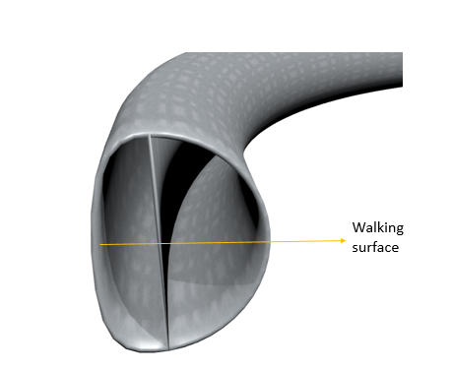

**5.7 CLOTHING:**

Clothing is an important factor for humans, it is one of the most important basic needs. To protect ourselves from the harmful effects of space we need to ensure a proper form of clothing. The various factors that must be considered for protection by clothing are:

* Containing of human Perspiration
* Anti-Microbial Properties
* Effects of spinning for production pseudo gravity
* Fire resistance
* Anti-static

Thus, to meet the following criteria we have carefully selected hybrid meta- materials that have high tensile strength and are durable.

The materials are to be used:

* *“Gore-Tex” source: (*[*https://en.wikipedia.org/wiki/Gore-Tex*](https://en.wikipedia.org/wiki/Gore-Tex)*)*
* *“Nano silver” source: (*<https://en.wikipedia.org/wiki/Silver_Nano>*)*
* *“Aramid FIBER” source: (*[*https://en.wikipedia.org/wiki/Aramid*](https://en.wikipedia.org/wiki/Aramid)*)*
* *G-suit*

The materials used help in protecting us from these above affects. The material “Gore-tex” is helpful water proofing as it is a good hydrophobic material, Nano silver is a good anti-microbial agent to protect the human body from foreign microbes, “Aramid fiber” is a heat resisting material that helps in protecting from the heat during any fire accidents and is also partially hydrophobic, and finally the G-suit since were rotating the structure to protect the body from the effects of rotating.

The suit is made with these materials so that they withstand the rough and tough gruesome handling which they will be subjected to, thus to make sure that there are no misshapes we make the suits extremely strong.

The first layer is made of G-suit which is about 0.1mm thick then a layer of Aramid fiber that is 1mm thick and is in sensitive parts of the body, these patches of aramid fiber is sown to the G-suit. The remaining open portion is sewn with the material Gore-tex. These suits are body fit and are specially made for an individual.

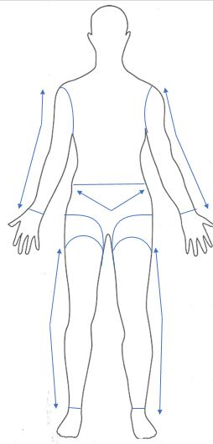

*Fig-26 A rough sketch of the suit. The blue lines and arrows representing the region where aramid FIBER and the empty region representing the Gore-tex.*

***5.7.1 EVA suits:***

EVA stands for Extra Vehicular Activity suits and these suits should be able to withstand the extreme space conditions in which the activities will be taking place thus, we must make the suits extremely comfortable and easy to handle in these conditions. Most of the space suits used in NASA are very heavy and difficult to put the suit on. We aim to make suits that last a life time so that we do not have the problem of wear and tear.

The following materials will be used in the EVA suits:

* *“SMA” (Shape memory alloy)*
* *Spandex*
* *“Nomex”*
* *“Tyvex”*

These materials will be able to protect the person wearing it, from the elements and people have the mobility required to move freely without any hassle and make repairs without any stress

These components are present in the space suit:

* Life support system (LSS)
* Temperature controller
* Pressure maintainer
* Interface
* CO2 gas nozzles
* Activity recorder

**Extra Vehicular support systems (EVSS):**

The Extra Vehicular support systems are designed to give out proper amount of oxygen and out-take proper amounts of carbon di-oxide, we will also be using humidity and sweat control systems which take care of the body in the space suits.

We will be releasing proper amounts of oxygen and intaking proper amounts of carbon di-oxide which will regulate the space suit with appropriate amount of gases. Another feature of the EVSS is to intake the sweat and smell which can cause discomfort in the person wearing it.

These units are designed in such a way that they are light and have all the necessities required in a space suit. They are done in such a way that there is no margin for error and if there are any problems there will be a backup for controlling the situation and assessing the problem.

**Temperature Control**

Temperature control is very important as the space vacuum has a very harsh environment and the temperatures can vary from 260 degree in the sunlight to minus 100 degrees Celsius in the shade, thus creating a need for temperature control. We should have systems that operate at high and low temperatures and can sustain the high temperature differences in the vacuum of space.

**Pressure:**

Pressure is important as it regulates the flow of blood in the body and in maintains the body pressure. The effects of less pressure in space can result in boiling of blood and exploding of body parts thus causing major injuries or even death for the person remaining unprotected in space. So, to keep people from blowing up we should maintain pressure in the space suits.

**Interface:**

The brains of the space suit will be consisting of a small minicomputer which will have all the stats of the space suit, and can act accordingly to the pressure and temperature variations and can help avoid further complications.

To give maximum comfort and help people have maximum mobility the interface will host a transparent OLED screen on the helmet to display.

**5.8 Temperature control**

Humans cannot live in freezing cold temperatures nor can they survive when the temperature is scorching hot. Thus, the temperature of the space settlement should be maintained so that any kind of discomfort is not felt by the residents. The temperature of the space settlement will be between 28 and 32 degrees Celsius. We have chosen these values as it is neither to hot nor too cold at these temperatures, people who are used higher or lower temperatures will gradually adapt to the temperature on the space settlement. The temperature on the space settlement will be controlled by a thermostat which will be managed by the quantum computer. The thermostats control the heating and air conditioning in the space settlement, these systems are operated by the quantum computer alone and humans will intervene only when a mishap occurs.

**5.9 Humidity**

The humidity of the space settlement will be maintained with the help of a water vapor recovery system or WVRS. The WVRS maintains the level of water vapor present in the air by absorbing water vapor and keeping the humidity constant throughout the space settlement. The water absorbed by the water vapor recovery system takes it to the desalination center for its reutilization. When humans respire, and sweat, some amount of water vapor goes in to the atmosphere. If the amount of water vapor increases in the atmosphere by human activities, the WVRS will automatically detect the increase in the levels of water vapor and absorb the necessary amount to bring back the normal humidity.

**6.0 TECHNOLOGY**

**6.1 POWER SUPPLY**

Energy is vital and is required to power up various components of the space settlement in the form of electricity. A regular power supply is very essential to power up the entire space settlement, for this we have devised a few methods to harvest energy on a large scale. Energy will be obtained through solar cells, the solar cells used in our settlement have been developed by “*Soitec”* and “*CEA-leti”* along with “*fraunhofer”* institute. These solar cells have achieved a maximum efficiency of 44.7%, this is the highest recorded efficiency rate ever developed by mankind. These multi junction solar cells will be using a new procedure called wafer bonding. These revolutionary cells are not only efficient but also cost effective. The amount of solar energy harvested by these cells are immense and the precise amount of energy produced by these cells will be explained later in the project. We will also be explaining the amount of energy consumed each day and how the left-over energy will be stored and utilized. The photovoltaic cells or solar cells are not the only technique through which energy will be produced, we will also be using kinetic tiles, EPGs (energy producing gymnasiums) as well as a biogas plant to harvest energy. Kinetic tiles are a newly devised innovative method for harvesting energy, these tiles harvest the kinetic energy obtained from people’s footsteps. The kinetic tiles used in our settlement would be acquired from a company called *“pavegen”.*

*“Source:* [*http://www.pavegen.com/what-we-do/*](http://www.pavegen.com/what-we-do/)*”*

Pavegen tiles are technologically advanced and have a triangular structure that maximizes energy production by triggering multiple generators per footstep. These tiles will be positioned almost everywhere in the settlement. The EPGS are another way to produce energy and will be separate for each living area. The people will be allotted a specific time to work out in the gym. The EPGS will be consisting of cycles, treadmills and various other gym equipment for the people to exercise. The gym equipment used in our space settlement would be taken from *“ARTIS TECHNOGYMS”*.

*“Source:* [*https://www.forumforthefuture.org/greenfutures/articles/uk-gym-converts-workout-energy-building-power*](https://www.forumforthefuture.org/greenfutures/articles/uk-gym-converts-workout-energy-building-power)*”*

*“ARTIS TECHNOGYMS*” claim that their equipment and technology is the most energy efficient on the market, with its treadmills consuming 30% less energy than comparable models. These gyms are self-powered and any surplus energy produced by the equipment will be channeled into graphene batteries, this energy in turn will be used to power up the space station or used for any other purpose.

The last method by which energy will be produced is through the biogas plants. The degradable wastes produced on the space station such as sewage, plant waste and food waste will all be transported to the biogas plant where they will be broken down in the absence of oxygen to produce gases. The gases obtained from the waste material will be utilized for powering up the space settlement. The exact amount of energy obtained from all these procedures and the energy consumption levels will be explained in the upcoming chapters of our project.

**6.2 ELECTRICITY CONSUMPTION:**

There are no sources in the current document.

Without electricity, no work can be done in the space station. To avoid any problems of energy crisis, we must be sure that that our electrical resources do not run out. Hence, we have a need to make sure that our energy production meets the energy demands of the space station.

POSEIDON’s outer surface will be covered with solar panels. These solar panels will be made up of Graphene. They will be able to harness 0.75kW per m2 of area. The outer surface of the Poseidon which will be covered by solar panels covers an area of 700000m2(7*105m2). We will be able to harness 525MWh of electrical energy.

The bio gas plant is humungous with very good electricity production efficiency. We can get 800m3 of bio gas from each ton of bio mass. Each hour, we produce about 0.6 tons of bio mass. This way, we produce 480m3 of bio gas per hour. For every cubic meter of gas, we produce 6kWh of electrical energy. This way, we produce 2.9MW of electrical energy per hour.

|  |  |  |
| --- | --- | --- |
| APPLIANCES | INDIVIDUAL CONSUMPTION | TOTAL CONSUMPTION(kWh) |
| COMPUTER | 250WH | 137.5 |
| OLED TV | 50WH | 864 |
| LAB EQUIPMENT | 5000WH | 120 |
| HARVEST CENTER | 420WH | 16.8 |
| DISHWASHER | 1KWH | 15 |
| PREPARATORY | 1KWH | 15 |
| DE-SALINATION | 1KWH/m3 | 14.4 |
| WATER PUMP(10HP) | 7.5KWH | 30 |
| QUANTUM COMPUTER | 20KWH | 60 |
| VR HEADSET | 2.5WH | 2.5 |
| OLED TVs AROUND OLA | 60WH | 29381 |
| UI | 1000WH | 1 |
| WASHING MACHINE | 500WH | 1152 |
| DRYER | 3000WH | 6912 |
| CCTV | 50WH | 3 |
| Others |  | 5 |
| TOTAL |  | 38729.2 |

**6.3 COMMUNICATION SYSTEMS:**

The communication systems main purpose is to help us stay connected with people and ensure we don’t miss out on any of our loved ones on the lunar base or Earth. The communication systems of HIVE will be made up of high tech communication equipment which can enable faster and high data flow rate in communicating with lunar base or earth.

***6.3.1 HOW IS COMMUNICATION USEFUL***

Communication is useful on many levels as it is the mode through which people can express their feelings and ideas. Thus, Communication is very important considering the large amount of data which will be coming to and FRO from the space station.

***6.3.2 WHAT MODE OF TRANSMISSION WILL BE USED?***

We will be using LIGHT as our mode of transmission in our space station and we intend to use this mode as it is the fastest mode of transmission currently and we do not want any disturbance in our communication so we are choosing light as our mode of transmission. The fastest mode of data transmission was achieved using light as the mode of transmission. The older method of data transmission was done using radio frequencies and huge unreliable data cables which resulted in lot of data loss and poor cable management.

***6.3.3 HOW WILL WE COMMUNICATE***

We will communicate with high powered lasers which have very less data loss rates and ensure that data is efficiently delivered. We will use lasers as they are capable of transmitting light in a very focused and efficient manner. We will not have any interruption’s and can ensure that we can communicate fast in case of any kind of emergency.

The first laser communication module in space was called “*SPOT 4” (Source:* *https://en.wikipedia.org/wiki/Laser_communication_in_space)* in 2001 it was operated with a speed of *10mbps*. we intend to use our laser communication at a speed of 1 terabytes per second, to ensure that there is efficient and endless data transmission in our space station. There will be 5 main laser communication and one 1 backup radio frequency for our communication systems in our space station. Another laser communication satellite reached speeds of 10 Gigabytes per second on their laser communication satellite called “*NFIRE and GERMAN radar satellite called TerraSAR-X”*

*Source:”*<https://en.wikipedia.org/wiki/Laser_communication_in_space>*”*

***6.3.4 WHICH EQUIPMENT WILL BE USED?***

The equipment used will be made up of meta-materials and high strength hybrid materials like carbine or Kevlar. There will be lasers which use up to 240 watts which is very less when we are transmitting data 1 terabytes of data every second.

We will also be planning to upgrade the laser communication to get higher data rates and take higher load when it is necessary for communication to operate at a higher load.

**6.4 NANO-BOTS:**

Nano-bots, the most revolutionary idea of the 21st century, has not yet been created. But we have given a brief explanation of it as it is very vital. It has many innovative approaches and implementations which can be very beneficial for us humans.

***6.4.1 DESIGN:***

The Nano-bots have a very simple design. It is basically a sphere. It has a very small cylindrical out growth which acts as an antenna.

***6.4.2 COMPONENTS:***

1. INFORMATION COLLECTOR: as the Nano-bots move around the body, a special machine will sense metabolic activities and collect information. This information will be in the form of binary codes. Each bot will for a specific and different purposes.
2. NANO DISCS: the info collected will be stored in Nano discs and can store up to 1Gb. Every time a person is scanned, all the information collected will be stored in a designated file in the quantum computer. The bot will wipe out that information once scanned or when the information has been sent to the quantum computer.
3. INTERPRETER: the information collected must be transferred to the quantum computer via RF frequencies. For this purpose, interpreters are installed in the bots to translate the collected information to RF frequencies.
4. RF TRANSMITTER: a machine located on the top portion of the internal part of the bot will be the transmitter. It will be connected to an interpreter and an antenna. The interpreter sends information to the transmitter which conveys it to the antenna.
5. ANTENNA: the antenna will send the information whenever a scanner send a signal to the antenna.
6. ENERGY: the adapter will be wirelessly charged. Whenever the person walks through an entrance which has chargers embedded in them, the bots get charged. The machine inside converts DC to AC. The AC is supplied to all the parts which need electricity. We chose AC as it is safer than DC and human life is more sacred than power losses.
7. NANO WIRES: these wires connect all the components of the bot as they need electrical supply to work.
8. PROPELLOR: in case the bot needs to move to a different place, the propellers will help it to.
9. RECEIVER: the receiver will receive wireless transmissions of electricity and pass it on to the converter.

***6.4.3 MATERIALS REQUIRED:***

The outer parts of the bots are ceramic. Ceramic bots will not alter any compositions of the blood as they are very neutral in nature. Blood will also not react with ceramic. Ceramics will not cause any problems for the internal parts of the body.

***6.4.4 POWER AND ELECTRICITY:***

In the entrance and exits of the residential area, wireless chargers will be located. These wireless chargers power the Nano bots. The receiver located in the bots will receive the energy from these chargers. This energy will be passed on to other components of the bots via Nano wires.

**6.5 DOCKING STATION**

The docking station is the final piece of Hestia and has two components, the first component consists of one cylinder, the second component consists of a docking port whose structure is given below. The dimensions of the port are given in the rocket section of the project.

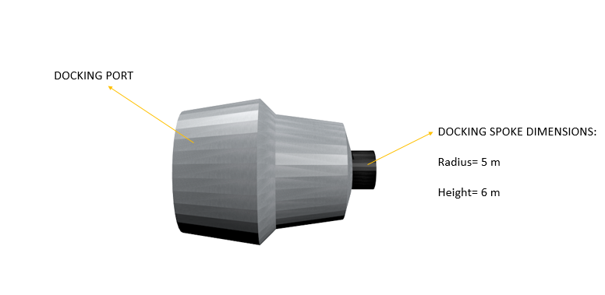

**Fig:28: Docking port**

***6.5.1 SPOKES***

There will be 16 spokes in total which connects all the various fragments of Hestia together. These spokes will also be used for moving and transporting numerous components from one portion of Hestia to another. There will be four internal spokes, four external spokes and 8 spokes dedicated to the docking station. The four internal spokes connect Pan to OLA and the four external spokes will connect OLA to Poseidon. The 8 other spokes have been used for the docking station. Since there are eight docking stations in total, one spoke will be dedicated to each docking station. The dimensions of these spokes have already been mentioned in the previous portions of Hestia’s design and is also given below

Internal spoke: Height = 122 meters and Radius = 10.5 meters

External spoke: Height = 50.6 meters and Radius = 10.5 meters

Docking station spoke: Height = 6 meters and Radius = 5 meters

**6.6 ROCKETS**

Transportation between earth and the settlement is essential. To transport people from earth to the settlement site we have built a distinct rocket that helps us in transporting people up and down. The rocket can carry 1440 people simultaneously. Thus, it would only take us approximately 8 rockets to fill the entire settlement. In the structure, there are separate docking stations that can hold our unique space ships called HSS. These rockets are specially made to carry only people and supplies. During emergency supply missions the rockets seating can be removed and can be filled with only supplies. The rocket can be basically described as a hemisphere surmounted on a cone. It has a cylindrical base where the fuel reserves and engine chambers lay. To initially launch the rocket a main thruster is built to provide enough momentum to propel it from earth. The thrusters fuel configuration is given in the table below:

|  |  |
| --- | --- |
| **Rocket Component:** | **Component Category/Name:** |
| Fuel | Liquid Hydrogen |
| Oxidizer | Liquid Oxygen |

The Rocket fuel used in our thruster is a standard liquid hydrogen (Cryogenic fuel) and a liquid oxygen oxidizer. The ratio of fuel mixture is 5.00 (Source : <http://www.braeunig.us/space/propel.htm>). The fuel also has a specific impulse of 381 seconds. Which is efficient to propel us from earth. The rockets thruster has a special fuel tank that is built around the circumference of the base. The rockets nozzles are placed on the circumference which are, secondary thrusters and the primary is ion thruster, it is in the exact center of the booster section of the rocket.

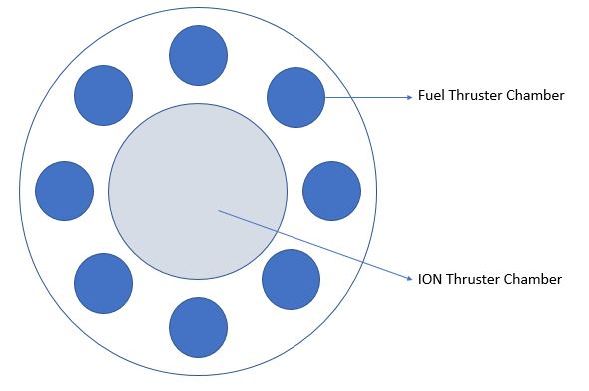

***Fig-29 Representing the positions of the thrusters.***

The fuel based thruster completely cuts off when it exits the earth’s atmosphere. Only the appropriate amount of fuel required to push the rocket is provided.

***6.6.1 ION Thrusters****:*

It is the most efficient types of thrusters available in this era of aerospace engineering. These rockets are propelled by using electric propulsion. These thrusters are propelled by using xenon as their fuel. For reaching moon’s orbit we need approximately about 604kgs of fuel. This could provide a propulsion of up to 10km/s. This is an efficient method of flying as not a lot of fuel is being wasted. On the Lunar base a xenon fuel reserve is built so that at times when we need to travel back to earth the rocket can go and refill. The amount of electricity that is needed to propel us at the speed of 10km/s we need about 5.2kw.

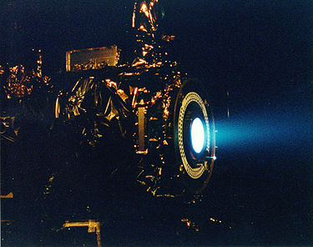

***Fig-30: A image of an ion thruster.***

***(Source:*** <https://en.wikipedia.org/wiki/Ion_thruster>***)***

***6.6.2 Fuel Thrusters:***

The thruster used to push us into earth’s orbit. This thruster requires 2 tons of liquid hydrogen and liquid oxygen fuel/oxidizer to propel us to earth’s orbit. It takes us only 150 seconds if we travel at the speed of 11km/s it takes only about 120 seconds to get out of earth.

***6.6.3 Sling shot:***

To conserve fuel and gain more momentum, the rocket revolves around the earth getting an assistance from the earth’s gravity and propelling itself to moon. Though we are using ion thrusters we need to conserve the xenon to propel us to moons orbit.

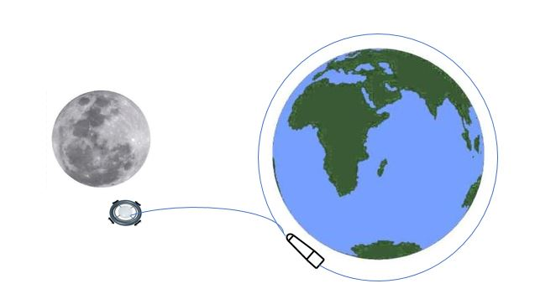

***Fig-31: Visual representation of the sling shot orbit and travel to Hestia.***

***6.6.4 Travel Time:***

The distance between earth and moon Is about 380,400km. When the speed of the rocket we intend to reach is about 10km/s. So, that means 36000 km/h. This will enable us to reach moon in only 10.6 Hours to reach the moon excluding the sling shot time. If we include the sling time it takes only about only 12 hours to finish sling shot and reach the moon.

*Rocket Structure and dimensions:*

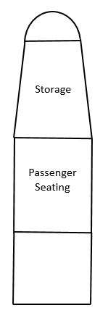

***Fig-32: representation of the sections of the rocket.***

The rocket has seating enough for only 1440 people. Since the section where people will be sitting is a rectangle we can divide them to 4 equal squares. Assuming each person takes only 1m2 of space we can sum up all the people’s area to 360m2. So, that is the square root of 360 which is approximately equal to 18.9m. The height of the people’s seating is 37.8m. we have given an extra 15m to fit in supplies. The engine chamber is 10m deep. This brings us to a total height of 65.8m. The rockets dimensions are given in the figure below:

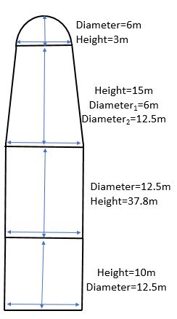

***Fig-33 Measurement of rocket.***

***6.6.5 Docking station:***

The station in the lunar orbit has a docking station to dock these rockets. On the side hatch of the passengers seating there is a protruding hatch that is connected to the docking station that has a claw like structure that hooks up to the hatch on the rocket. In the adjoining figure the dimensions of the docking station are given. To transport supplies from the upper portion are sent down the hatch and transported to the main structure. The seats can be retracted to the floor of the shuttle hence making up space for movement of goods to move. The rocket will be docked horizontally to the structure. There are 8 docking station every 446.89m of the circumference of the POSIEDON structure. Each of these are placed at 45 degrees to each other. Therefore, it makes it easier for people to get out of the rocket and enter the structure with ease.



***Fig-34 Measurements of the docking station (SPOKE DIMENSIONS)***

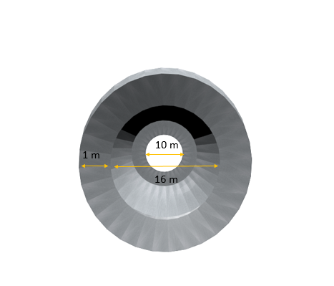

***Fig-35 Measurements of the docking station (DOCKING PORT DIMENSIONS)***

**7.0 Human Resource**

**7.1 LAW ENFORCEMENT**

***7.1.1 CONSTITUTIONAL AND ADMINISTRATIVE LAWS:***

The government of Hestia will be divided into three components. The functions and powers of the government will be divided among these three parts.

MEROS 1: there are 11520 people in our settlement out of which 11250 are residents. They will be monitored by 250 representatives. Each of these 250 representatives will manage 45 people. A collection of 45 people will be called a group. These representatives will supervise every action of the members of their group. They will set schedules, mentor them and help them in their day to day activities if required. The representative will be known as meso for agent in Greek.

MEROS 2: there are 10 other residents who will monitor the activities and performances of the leaders of the 45-group people. They will limit the powers of the representatives to prevent misuse of authority. Each of these representatives will monitor 25 of the leaders of first group. They will answer to the presidents who will take further action. The leader will be known as igetis for leader in Greek.

PRESIDENTS: one person running the whole settlement con sometimes come under a lot of pressure and might be called dictatorship by some. To prevent any mishap, we will appoint two presidents. These presidents will be split personalities of each other who respect each other mutually but not necessarily agree on all aspects of discussion. In case the presidents do not reach a conclusion, they will call a board meeting with the 8 judges and 10 other main leaders, who will take a vote and collectively reach a conclusion.

***7.1.2 CRIMINAL LAW:***

Depending on the amount of damage caused or crime done, the punishment will be awarded to the accused by the judge.

The accused will not have the right to lawyer but instead he will be asked to talk for himself. If he will not be able to talk for himself, he has the right to appoint someone to represent him.

When the accused is on trial, he will not be thrown off into a prison rather confined to a special part in OLA2 as he does not have any ‘space’ to run off to LOL. If he is found guilty, the punishment will be decided by the judge. He may be sent off to a short-term exile, imprisoned to a very small space or the judge might decide depending on the felony.

***7.1.3 LAW ENFORCERS AND ENFORCEMENT:***

To protect and help 11520 people of HESTIA, we will deploy 60 police officers in one shift. 55 of these officers will be patrolling the station always. 5 other superiors will be supervising the activities of the other officers. These five officers will in turn answer to one commissioner. This commissioner will lead and direct all the police officers of all shifts. The commissioner must answer to the president in case he is needed.

CCTVs cameras will be installed and monitored by officials. Since the settlement is very huge, all the CCTV footage will not be monitored by officials. Instead, officials will monitor only the areas of interest.

Radio receivers will be installed in certain places. These radio receivers prompt the Nano-bots to send a short radio message. This radio message has the details of the details of the person. This way, anybody in HESTIA can be tracked with a click of a button. It may not be very efficient or precise but we use all our resources and helps in case of budget shortages.

If a person is found to make a felony, he will be immediately tracked down by the police. The police will cuff him and take him to the isolation center. He will be provided all materials which will assist him to prepare his defense in case there is one. When the time comes, the police will escort him to the hearing.

If he is found guilty, he will be punished aptly.

If he is not found guilty, he will be given a compensation for the wastage of his time.

**7.2 DAY AND NIGHT**

The factors which affect the human body the most are our time periods and our classification of time we rest along with the time in which we are active. These two factors decide our habits and our schedule for the day. They also provide the optimal rest time and active time for each person. We composed the day and night in HESTIA as per the time which we spend on Earth so that our patterns of living do not get tampered with.

There will be specific patterns of schedule for each sector and they will always be different from one another. This is to ensure that at any given point of time people will always be active and on board crew will be present to monitor the space station. There will be 12 sectors for residential area and at any given point of time there will be 66.67% of active population in the space station.

There will be 3 groups in the residential area each containing 4 sectors and there will be 8 hours of gap between each schedule, to complete 24-hour cycle and maintaining 66.67% of active population at any given time.

The schedule will be as follows For Group 1:

|  |  |
| --- | --- |
| **Timing:** | **Event:** |
| 06:00 | Waking up |
| 06:00-06:30 | Work Out |
| 06:30-07:30 | Grooming |
| 07:30-08:20 | Breakfast |
| 08:20-08:30 | Work place transportation |
| 08:30-12:30 | Work |
| 12:30-13:10 | Lunch |
| 13:10-16:00 | Work |
| 16:00-16:30 | Snacks |
| 16:30-18:30 | Leisure Time |
| 18:30-19:00 | Sterilization |
| 19:00-20:00 | Dinner |
| 20:00-21:00 | To Time |
| 21:00-06:00 | Sleep |

The schedule below will be for Group 2 which will house 4 sectors and the clocks have been set 8 hours ahead of the group 1.

|  |  |
| --- | --- |
| **Timing:** | **Event:** |
| 14:00 | Waking up |
| 14:00-14:30 | Work Out |
| 14:30-15:30 | Grooming |
| 15:30-16:20 | Breakfast |
| 16:20-16:30 | Work place transportation |
| 16:30-20:30 | Work |
| 20:30-21:10 | Lunch |
| 21:10-24:00 | Work |
| 24:00-24:30 | Snacks |
| 24:30-2:30 | Leisure Time |
| 02:30-03:00 | Sterilization |
| 03:00-04:00 | Dinner |
| 04:00-05:00 | TV Time |
| 05:00-14:00 | Sleep |

The schedule below will be for Group 3 which will house 4 sectors and the clocks have been set 8 hours ahead of the group 2.

|  |  |
| --- | --- |
| **Timing:** | **Event:** |
| 10:00 | Waking up |
| 10:00-10:30 | Work Out |
| 10:30-11:30 | Grooming |
| 11:30-12:20 | Breakfast |
| 12:20-12:30 | Work place transportation |
| 12:30-4:30 | Work |
| 4:30-5:10 | Lunch |
| 5:10-8:00 | Work |
| 8:00-8:30 | Snacks |
| 8:30-10:30 | Leisure Time |
| 10:30-11:00 | Sterilization |
| 11:00-12:00 | Dinner |
| 12:00-1:00 | TV Time |
| 1:00-10:00 | Sleep |

**8.0 LUNAR BASE**

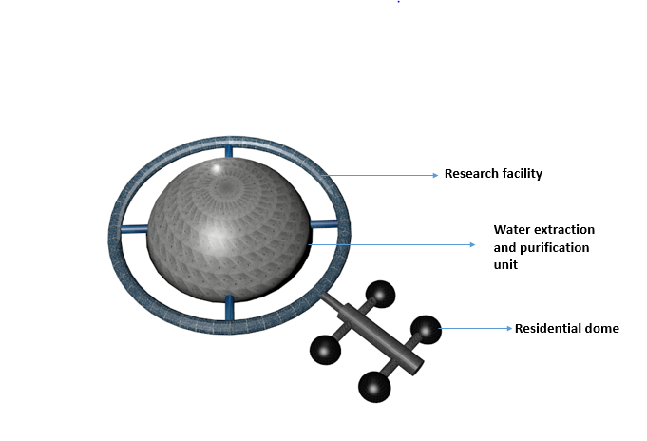

**Fig-36: lunar base**

The lunar base is a very essential component to Hestia as it provides a regular supply of water, people will also visit the surface of the moon and take in the experience. The lunar base has been placed at a distance from the shadowed regions of mars where water is present. These shadowed regions of mars are very cold places with temperatures reaching -249 degrees Celsius, these regions are present at the poles of mars. Since we cannot make the lunar base in this region, we will place it somewhere near the shadowed region so that we can extract a regular supply of water from this region. The lunar base also has a research facility where elite scientists will carry out research. For exploration, 500 people will be sent from Hestia to the lunar base so that the people can explore the surface of moon.

**8.1 DIMENSIONS OF THE LUNAR BASE**

The lunar base consists of several components, there will be one water purification dome, one research tori, four residential domes and 10 spokes. The dimensions of these components have been given below.

***8.2.1 WATER PURIFICATION DOME:***

The water purification dome has a radius of 60 meters and is used to purify the water obtained from the shadowed regions of mars. A few pipelines made of aerogel will be placed between the shadowed region of mars and the water purification dome. These pipelines will supply water from the shadowed region to the dome. We have chosen aerogel over other materials because aerogel wouldn’t become brittle and breakdown if exposed to very cold temperatures. An ice melting apparatus will be placed in the shadowed region of mars and this machine will melt the ice and supply the water obtained to the pipes which will take the water to the water purification dome. The ice melting machine will also be made of aerogel. An RTG (radioisotope thermoelectric generator) will be placed next to the ice melting apparatus to supply electricity to produce heat, this RTG will be coated with a thick layer of aerogel so that it can resist the cold temperatures. The RTG uses a radioactive isotope to produce electricity and this electricity will be supplied to the ice melting apparatus to melt the ice. The extracted water will be purified in the water purification dome and then safely stored for utilization.

***8.2.2 RESEARCH TORI:***

The research tori have a minor and major radius of 5 meters and 85 meters respectively. This torus has been dedicated only for research and scientists will carry out all kinds of research in the various field of science, the research facility has lots of space and will also be used as a living space if necessary. The main objective of this research facility is for humanity to discover and reach greater heights in the fields of science. The research torus is covered completely with solar panels to harvest energy.

***8.2.3 RESIDENTIAL DOME:***

The residential dome has a radius of 10 meters and is the place where people live. The residential dome consists of all the peoples’ requirements. The cafeteria, defecating area, bathing area, entertainment area and sleeping area have all been placed in this dome. The people from Hestia who visit the lunar base will stay in these residential domes and if we want to accommodate more people they will live in the research tori which has all the facilities required except for entertainment. The people who live in the research tori will go to the residential domes for entertainment.

***8.2.4 SPOKES:***

There are 10 spokes in total and these spokes connect the various parts of the lunar base together. There are four internal spokes and 6 external spokes. The internal spokes connect the water purification dome to the research torus and the external spokes connect the residential domes to the research torus. The internal spokes have a height of 20 meters and radius 3 meters; all the internal spokes have the same dimensions. There are 5 external spokes and 4 of them have the same dimensions while one of them has different dimensions. The 4 external spokes that are like each other have a radius of 3 meters and a height of 15 meters, the 5th spoke that is different from all the others has a radius of 6 meters and height of 60 meters.

**9.0 Conclusion**

This project mainly aims to provide shelter for people in space no matter what. This will also bring chances of finding extra-terrestrial life on moon as well as outer space. People will have a new understanding of space and how it works. They will have new interest in them to help in astrophysics. This will help in motivating many more physicists to gain more knowledge about the subject. People will now have new home.

PROJECT Hestia also brings together people of different nationalities under one roof. This will help strengthen the bonds between all the countries of the world and increase world peace.

The mind boggling questions can also be answered by doing various researches on Moon. Many other types of equipment can be taken along to know more about our universe. The space stations can be increased further to accompany all the other people on earth in case of any mishap.

This project has high hopes as it is much rational and the earth is very unstable so it will attract a lot of people.

**Bibliography:**

1) Graph representation of quantum computer database search-

*(Source-*<https://jasonkatsarosblogfolio.wordpress.com/2015/10/22/why-quantum-computing-is-the-new-sliced-bread/> ). Page number: 41

2) “The experience of the user, excreta and wastewater collection methods, transportation or conveyance of waste, treatment, and reuse or disposal all need to be thoroughly considered”. *(Source:* [*https://en.wikipedia.org/wiki/Sanitation*](https://en.wikipedia.org/wiki/Sanitation)*) .* Page number: 57

3) “The condensed aerosol micro particles and effluent gases are generated from an exothermic reaction; these particles remain in vapor state until they are discharged from the device. They are cooled and condensed in the device and then are released as solid particles”.

<https://en.wikipedia.org/wiki/Condensed_aerosol_fire_suppression>

Page number: 67

4) *Source:* <https://ntrs.nasa.gov/archive/nasa/casi.ntrs.nasa.gov/20160003078.pdf> Page number :71

5) “Gore-Tex” source: (<https://en.wikipedia.org/wiki/Gore-Tex>)

Page number: 75

6)“Nano silver” source: (https://en.wikipedia.org/wiki/Silver_Nano) Page number: 75

7)“Aramid FIBER” source: (<https://en.wikipedia.org/wiki/Aramid>) Page number: 75

8)”ARTISTECHNOGYMS”*Source:*https://www.forumforthefuture.org/greenfutures/articles/uk-gym-converts-workout-energy-building-power*”* Page number:79

9) “*NFIRE and GERMAN radar satellite called TerraSAR-X”*

*Source:”*<https://en.wikipedia.org/wiki/Laser_communication_in_space>*”* Page number: 82

10) Ion Thruster “***(Source:*** <https://en.wikipedia.org/wiki/Ion_thruster>***)”*** Page number: 88

11) Google “(source: <https://www.google.com>)” Page number:18

12) Wikipedia “(source: <https://www.wikipedia.co.in>) Page number: 18